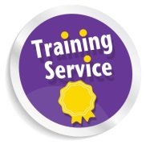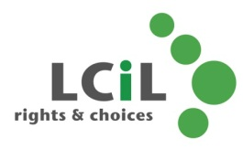

**Are you:**

* **A Parent/Carer thinking of employing PAs on behalf of someone?**
* **Managing a support package on behalf of a supported person?**

**Then help is on the way!**

**FREE PICK AND MIX TRAINING**

Two workshops to help you increase your confidence and skills in managing a direct payment and get to grips with what you need to do to report to the local authority.

Topics will include:

* Identifying the key skills and responsibilities of a good employer
* Feeling more confident to develop good communication and avoid conflict with staff

LCiL Independent Living Team members and Payroll staff will be available to help with specific issues

For more information on the content of each workshop see over the page!

**Dates: 3 and 12November, at Musselburgh East Community Centre**

**MC900036405[1]Times for 3 November: 10.30am-1.30pm**

**Times for 12 November : 5.30pm – 8.30pm**

Light refreshments with be provided at all sessions.

**For more information contact Amanda Beech Training Officer at LCiL on 0131 475 2350 or email:** [**amanda.beech@lothiancil.org.uk**](mailto:amanda.beech@lothiancil.org.uk)





**You can come to one or both of these workshops:**

**Employer responsibilities and managing staff**

**Tuesday 3 November** (10.30am-1.30pm at Musselburgh)

The bite-size workshop topics will include:

* Identifying key responsibilities and skills of a good and efficient employer
* Identifying key rights of PAs and understanding how to avoid employer/employee conflict
* Identifying strengths and areas for development in your own staff management skills.
* Feeling more confident and informed about how to treat staff fairly and equally and avoid discrimination
* Identifying how to develop good communication with staff and reduce potential conflict

**Managing payroll and HMRC paperwork/recording as**

**a PA employer**

**Thursday 12 November** (5.30-8.30pm at Musselburgh)

The bite-size workshop topics will include:

* Identifying and prioritising the administrative tasks needed to manage a direct payment and employ PAs
* Identifying key responsibilities with HMRC and LCiL Payroll
* Developing a personal admin system
* Feeling more confident and informed to deal with Payroll paperwork/recording

At each workshop members of LCiL staff from the Independent Living Team and the Payroll service will be available to help with specific issues

At a later date there will be optional follow up sessions. These will give you the opportunity to:

* share experiences with others in a safe and understanding environment
* be signposted to other LCiL services/support