[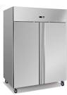](http://www.google.co.uk/url?q=http://www.businessmagnet.co.uk/company/airconditioningkent-161691.htm&sa=U&ei=ffbYUoyBM5OZhQetrYHYAw&ved=0CDAQ9QEwAA&usg=AFQjCNH7FUQvQAlXfdM7f95zxRVZkoS1-g)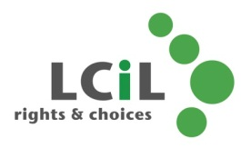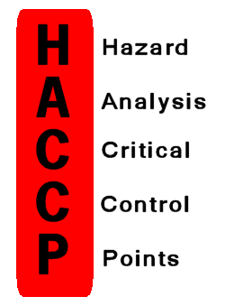MC900250740[1]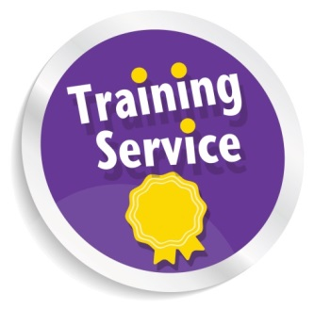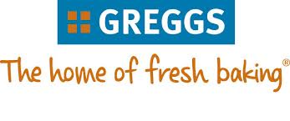MC900432423[1]

**Date: 9th September 2015**

further dates to come later in the Year!

**Time**: 11.30am—3pm

**Venue:** Greggs Bakery, Greggs Bakery, 36, Dryden Rd, Bilston Glen Industrial Estate, Midlothian EH20 9LZ

Rights & Choices for

Disabled people, people with long term conditions and older people in

Edinburgh and Lothian

* learn more about contamination of food – Do’s and Don’t’s
* Personal hygiene and hand washing
* Storage of food and industrial kitchen safety
* Better understanding of working with food and more!

The next 3 hour training course for disabled people who want to learn more about food safety in the workplace is now here! If you have already come onto the course and you are interested in finding out more, this is for you!!

**Email**: amanda.beech@lothiancil.org.uk

**Phone**: 0131 475 2510

**Address:** 57 Albion Road

Edinburgh

EH7 5QY

Food

Safety and Quality in the Workplace Course

LCiL Training Service

In Partnership with Greggs...

Transport costs provided on request

**Refreshments provided by Greggs**