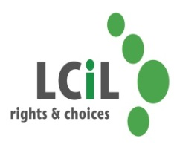

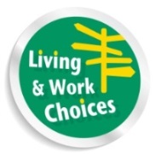

**Are you a disabled person or have a long term health condition & live in the Lothian area?**

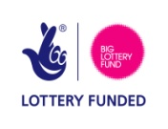

**Do you want to become more confident and positive about your future?**

**Then book a place on our Personal Development Day**

**On**

**Thursday 5th February 2015 in Edinburgh**

Lothian Centre for Inclusive Living is running a series of four day courses covering a range of topics aimed at supporting disabled people and people with long term conditions to maximise their potential and participation in community life. Course topics include Session one: Personal Development (Confidence Building etc), Session two: Equality, Session three: Self Directed Support & Planning for the Future, Session Four: A Working Life.

**C:\Users\elspeth.ferguson\AppData\Local\Microsoft\Windows\Temporary Internet Files\Content.IE5\3GIR52RI\MC900320976[1].wmfC:\Users\elspeth.ferguson\AppData\Local\Microsoft\Windows\Temporary Internet Files\Content.IE5\3GIR52RI\MC900320976[1].wmf**LCIL invite you to our next FREE Personal Development Day at Norton Park Centre, 57 Albion Road, Edinburgh, EH7 5QY on Thursday 5th February 10.30am-3.30pm (lunch included)

**Transport can be arranged if required**

To find out more & to register your interest please:

Telephone Elspeth or Kelly at LCIL on 0131 475 2350

Email either [elspeth.ferguson@lothiancil.org.uk](mailto:elspeth.ferguson@lothiancil.org.uk) or

[kelly.jack@lothiancil.org.uk](mailto:kelly.jack@lothiancil.org.uk)