C:\Users\amanda.beech\AppData\Local\Microsoft\Windows\Temporary Internet Files\Content.Outlook\PHG9CIFW\new logo.bmp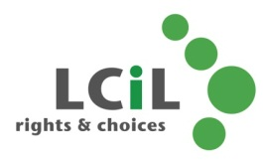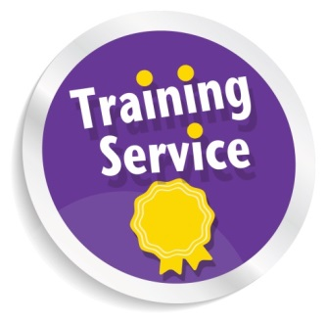C:\Users\amanda.beech\AppData\Local\Microsoft\Windows\Temporary Internet Files\Content.Outlook\PHG9CIFW\new logo.bmpMC900432423[1]MC900250740[1]MC900286855[1]

**Is back, with even more dates to come!**

  • Bacteria and causes of food poisoning

• Personal hygiene and hand washing

• Storage of food and kitchen safety

• Choosing the healthy option and more!

The popular 4 hour training course for disabled people who want to learn more about:

**Email**:amanda.beech@lothiancil.org.uk

**Phone**: 0131 475 2510

57 Albion Road

Edinburgh

EH7 5QY

Introductory Health & Food

Safety Course

LCiL Training Service

In Partnership with Greggs...

**The date for the next course is now here!**

**Date:** 29th April 2015 **Time**: 11.30am—3.30pm

**Venue:** Greggs Bakery, Greggs Bakery, 36, Dryden Road, Bilston Glen Industrial Estate, Midlothian EH20 9LZ

**So if you are interested book now!**

**Refreshments provided by Greggs**

Rights & Choices for

Disabled people, people with long term conditions and older people in

Edinburgh and Lothian