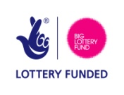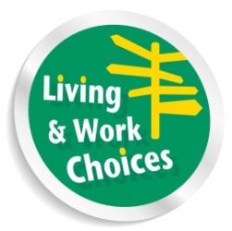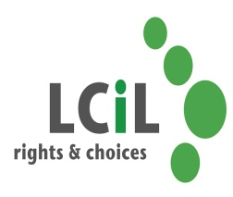

**FREE**

**Essential PA Employer Skills Course!**

**Are you a disabled person or a person with long-term condition?**

* **Thinking about employing Personal Assistant(s) to support you?**
* **Or, if you are already a PA employer, want to refresh your employer skills?**

The **Essential Employer Skills** is a 3 day course that provides disabled employers of Personal Assistants with an understanding of the essential responsibilities and roles required of a good employer.

**Gain more confidence in managing your PA!**

When: **1st, 6th & 8th October 2014! 10.30am - 3.30pm**

**LUNCH PROVIDED**

**TRANSPORT CAN BE ARRANGED IF REQUIRED**

Where: **Norton Park, 57 Albion Road, Edinburgh**.

The course will enable participants:

* to gain an overall understanding of the key responsibilities of an employer
* to better understand what is involved in recruitment of a Personal Assistant ***(optional for existing PA employers)***

**Course will be delivered by a disabled PA employer**

* to gain skills in effective PA management
* to determine boundaries to promote good employer/employee relationships
* gain more independence and control
* to increase self confidence

**To register your interest or for an informal chat to find out more about the course, please contact LCiL on 0131 475 2350 or email either** [elspeth.ferguson@lothiancil.org.uk](mailto:elspeth.ferguson@lothiancil.org.uk) or [kelly.jack@lothiancil.org.uk](mailto:kelly.jack@lothiancil.org.uk)