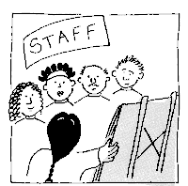
Training for Personal Assistants
It could change your life!
is back!!!
Thinking about becoming a PA?
Or
Want to brush up on your PA skills?

This 2 day Training for Personal Assistants course, which has proved so successful since coming back, is being run again on 18th and 19th Nov 2014. It could enhance your prospects of employment as a PA or, if you are already a PA, help you to be more effective in your role.
Topics covered include:
- Disability and Equality - cultural representations of disabled people and barriers faced by disabled people
- Social Model of Disability – and how to apply the principles in your PA role
What are you waiting for?
Learn today!

- Understanding the importance of appropriate
language
- Exploring roles and relationships
- Knowing the Relationship Boundaries
- Exploring potential dilemmas
- Responding to Your Employer’s Needs

Dates: 18th and 19th Nov 2014. Time:10.00am to 4.00pm (Lunch provided)
Venue: Norton Park, 57 Albion Road, Edinburgh. EH7 5QY
Are you eligible for ILA funding? If so, you can use it to pay for this course. To find out more, visit www.ilascotland.org.uk or visit our website Now !
www.lothiancil.org.uk for ILA 200 Eligibility Criteria. For non-ILA holders, the cost will be £195 for the two days
For more info email: training@lothiancil.org.uk or visit LCiL website:
Book your place now!
Amanda Beech on 0131 475 2510
Book your place!!!!!

Participant Feedback:
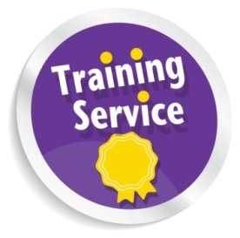
“ I found it informative from start until the end! Great time!!!”
“I was not thinking of becoming a PA until I came on the course with my partner but, now I am full-time PA and I love my Job”

