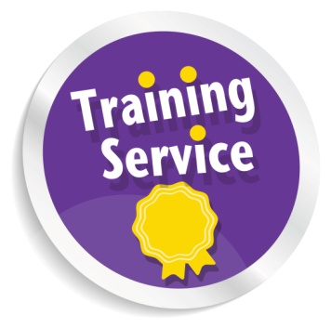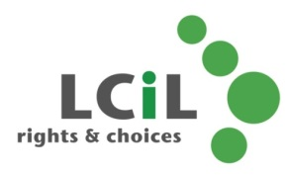

Phone: 0131 475 2350

Fax: 0131 475 2392

Email: [training@lothiancil.org.uk](mailto:training@lothiancil.org.uk)

Online: [www.lothiancil.org.uk](http://www.lothiancil.org.uk)

 Find us on Facebook

 Follow us on Twitter

Our opening hours are Monday – Friday,

10am-4pm.

Address: Training Services, LCiL, Norton Park, 57 Albion Road, Edinburgh, EH7 5QY. (Our offices are fully accessible, with parking available).

A full training programme is also available to disabled people.

**For further information please contact:**

**Training Opportunities for Organisations**

**Lothian Centre for Inclusive Living**

LCiL is a registered charity number SC017954

Pictures from CHANGE Picture Bank & London People First

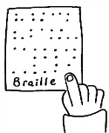MC900351591[1]Fax 

For both individuals and organisations on topics such as Disability Equality and self-directed support, including be-spoke training.

.

Information is available on request in a range of formats:

**Audio Braille Easy words Large Print**

**Tel: 0131 475 2350**

**Email:** [**training@lothiancil.org.uk**](mailto:training@lothiancil.org.uk) **Website: www.lothiancil.org.uk**

**Packages and costs**

LCiL can work with you to develop a complete package to meet all your organisations training needs and discuss options for your staff and/or service users.

Depending on the training, LCiL can access funding and may be able offset some of the costs.

Please do get in touch to ree quote and to hear what we can offer you u within your budget.

Our training courses are participative and user friendly whilst supporting people to explore changes in traditional ideas about disability.

Training courses available can include:

* Disability Equality
* Disability Etiquette
* Disability Discrimination Act/Equality Act 2010
* Self-Direct Support & Independent Living
* Personal Assistant (PA) Employer Skills & Responsibilities.

Full details of what these training courses consist of can be found on our website or you can contact us directly using details on the back page.

**What we can offer**



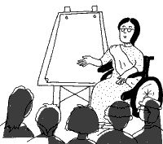

**The Training Service is part of LCiL:**

LCiL works with disabled people, people with long-term conditions and older people, parents and carers in Edinburgh and the Lothians.

We support people to take control of their own lives, support their choice to take up their rights and enable their full participation in society,

and to:

* live more independently
* be more in control
* use self-directed support

We are able to tailor our training to fit your specific requirements and will:

* Ensure that you are up to date with Disability and Independent Living Issues.
* Offer a flexible approach to your training needs.
* Enable you to access resources which have been developed by a user led organisation of disabled people, committed to inclusion.