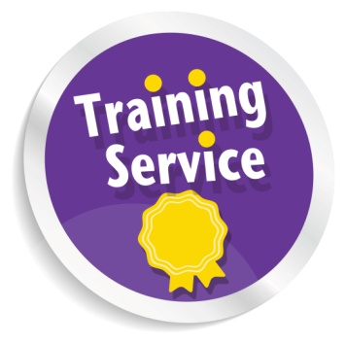

**Training Opportunities for Disabled People & People with Long-Term Conditions**

Phone: 0131 475 2350

Fax: 0131 475 2392

Email: [training@lothiancil.org.uk](mailto:training@lothiancil.org.uk)

Online: [www.lothiancil.org.uk](http://www.lothiancil.org.uk)

 Find us on Facebook  
 Follow us on Twitter

Our opening hours are Monday – Friday,

10am-4pm.

Address: Training Services, LCiL, Norton Park, 57Albion Road, Edinburgh, EH7 5QY

(our offices are fully accessible, with parking available).

A full training programme is also offered to organisations in a separate leaflet.

**For further information please contact:**

**Lothian Centre for Inclusive Living**

LCiL is a registered charity number SC017954

Pictures from CHANGE Picture Bank & London People First

MC900351591[1]Fax 

Are you a disabled person or a person with a long term condition living in Edinburgh and the Lothians who would like to:

* Find out what learning opportunities are available?
* Find out more about your Independent Living options?
* Find out more about being an employer of Personal Assistants?

Information is available on request in a range of formats:

**Audio Braille Easy words Large Print**

**Tel: 0131 475 2350**

**Email:** [**training@lothiancil.org.uk**](mailto:training@lothiancil.org.uk)

**Website: www.lothiancil.org.uk**

* Create learning opportunities where Disabled People can feel comfortable and supported.
* Encourage Disabled People to develop their self-awareness and self-confidence.
* Support Disabled People who want to gain information and practical skills with regard to being a Personal Assistant (PA) employer.

There is an emphasis on issues

around Independent Living, and

being a Personal Assistant

employer, as these topics

are most relevant to the disabled

people we work with.

**How LCiL can help?**

In order to assist you to take full advantage of the learning opportunities we offer, if requested or required, we will be happy to:

* Come out and talk to you in your own home about any questions you may have about training.
* Carry out a personal training needs survey with you.
* Discuss the training and any arrangements for courses/workshops with you before you book a place
* Try to be as flexible as possible in order to accommodate any requirements that you may have.
* Provide assistance with transport to the training (depending on funding).
* Provide personal assistance on the day of training.

**The aims of LCiL's training service are to:**



**LCiL provides free training opportunities, (when funding available) including:**

* Living Choices (Independent Living &

Self-Directed Support)

* Assertiveness and Self Esteem
* Health and Safety
* Managing Conflict
* Employer Obligations and Good Practice
* Dealing with Niceness

LCiL training is:

* Accessible, informative, enjoyable & flexible.
* Devised in partnership with, and delivered by, disabled trainers.

**LCiL also provides:**



* An **Independent Living Service** offering one-to-one advice and support to manage your own support package.
* A **Payroll Service**, freeing you from some of the paperwork needed to be an employer.
* Information and advice to individuals and employers on using **Access to Work** to assist disabled people to start or remain at work.
* **Grapevine** which offers free, confidential information and advice, on any disability matter.