
Lothian Disability News
Summer 2014

Successor to the Independence Living Fund in Scotland!

LCiL were delighted to hear that a new Scottish Independent Living Fund (SILF) will be set up in 2015, when the current UK fund closes.
In an annoucement in April the Scottish Government said the new Fund will protect existing Independent Living Fund (ILF) users packages, safe-guarding support given to more than 3,000 disabled people across Scotland. It is intended to build on existing support through a £5.5 million investment which should re-open to new users, ensuring a long-term future.


The current ILF has been closed to new claimants since 2010. Many exisitng ILF recipients rely on it to provide vital everyday assistance which enables them to remain living at home and participate in work, training and education.

When the current UK Government’s support scheme closes in June 2015 it is proposed that Scotland set up its own arrangments to develop a national system possibly run by a voluntary organisation.

LCiL, along with other organisations in the Independent Living Movement in Scotland, has been calling on the Government to secure the Fund for existing users and new people who could benefit from it for a number of years. Many disabled people in Scotland benefit from accessing this fund, enabling them to live more independent lives and be part of their community.
In this edition:
- Happy 1st Birthday LCiL Champions & their new video - page 7.
- Self-directed support translation guide – page 3.
- Internships for disabled people – page 8.
- Next Midlothian benefits cuts group – page 13

We will continue to work with our partners and disabled people to ensure that there is a fair and transparent ILF for disabled people across Scotland which meets the needs of existing and new service users. We will keep you posted on further announcements and consutaltions.
Lothian Disability News is written and produced by Grapevine, Disability Information Service, which is run by the Lothian Centre for Inclusive Living (LCiL).
Grapevine, LCiL, Norton Park, 57 Albion Road, Edinburgh, EH7 5QY Tel 0131 475 2370
Email grapevine@lothiancil.org.uk Website: www.lothiancil.org.uk

Grapevine, LCiL, Norton Park, 57 Albion Road, Edinburgh, EH7 5QY Tel 0131 475 2370
Email grapevine@lothiancil.org.uk Website: www.lothiancil.org.uk


Lothian Centre for Inclusive Centre (LCiL)
News and events:

Making self-directed support work
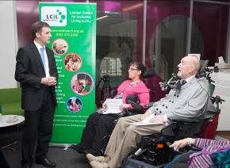
The Social Care (Self Directed Support) (Scotland) Act came into force in Scotland on the 1st of April. LCiL in partnership with the Scottish Government hosted a national event to formally celebrate the official launch of this landmark piece of legislation.

People who will benefit from self-directed support (SDS), carers, agencies and professionals involved in offering SDS joined us on the day, along with the Minister for Public Health, Michael Matheson. The event was broadcast live from the LCiL website on the day so that others could be part of celebrations and join in the debate on social media, including on Twitter by using the hashtag #makeSDSwork. Individuals spoke about their hopes and expectations for SDS which can be viewed in a short film on our website: http://www.lothiancil.org.uk/get-involved-with-lothian-cil/makesdswork/

The ideas behind self-directed support (SDS) have been gaining momentum over a number of years amongst disabled people, and now the right to have choice and control over how support is organised and delivered is enshrined in law. The hope is this will ensure that more disabled people and people with long term conditions can organise their support in a way that suits their lifestyle, wants and needs, instead of it being decided for them. All local authorities have a statutory duty to give people who are eligible for support choice, including 4 options on how their support can be designed and delivered, these are:

Option 1 – the person receives a direct payment and arranges the support themselves, often with the support of an advice and support organisation

Option 2 – the person chooses how their individual budget is spent while the local authority or a third party (such as a support organisation or service provider) manages the money and arranges the support on their behalf

Option 3 – the person asks the local authority to decide and arrange the services and support they receive

Option 4 – a combination of two or all of options 1, 2 and 3. For example, the person may choose to use part of the budget as a direct payment to employ a personal assistant and another part to receive a service decided and organised by their local authority.

LCiL is working closely with disabled people, and those who support them, including local authorities, voluntary sector services, carers and family members to ensure the law becomes reality. Within LCiL the Champions, a group of disabled people who are proactively engaging in initiatives to ensure that the ideas around choice and control work in practice for individuals, have done a lot of work with local authorities. Robert, a Champion talks about his experiences so far on page 7.
SDS resources:
We are also building resources to assist disabled people - and those supporting them to use SDS on the LCiL website in our E-library under the Self-Directed Support category which can be accessed for free at: http://www.lothiancil.org.uk/e-library/
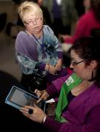
This includes guides, developed by the Scottish Government in partnership with agencies, on SDS for users, carers and practitioners.

In the photo the left you can see Katrina, an LCiL Independent Living Officer, using a new application based on the users guide for SDS which can be used on I-phones and I-pads.

Myth busting and breaking down barriers



Last month LCiL in partnership with MECOPP, the Black and Ethnic Minority (BME) carers’ agency, hosted an event to bring professionals and others involved in using self-directed support, together. The day provided an opportunity to talk about some of the issues facing BME disabled people. Omar Haq in the photo spoke about his experience as a BME disabled person and how he maintains independence in aspects of his daily life.
Translation guide:
MECOPP have also produced a useful Self-Directed Support (SDS) Translation guide which includes some key SDS terms in different languages and descriptions. Using everyday language, the guide uses plain English descriptions for words such as ‘coproduction’, ‘outcomes’ and ‘financial assessments’, in different languages including Bengali, Chinese, Punjabi and Urdu and English. You can donwload a copy for free from the MECOPP website at: http://www.mecopp.org.uk/resources-sds_translation_guide.php?section_id=331. Alternatively you can call them on 0131 467 2994 for a hard copy.

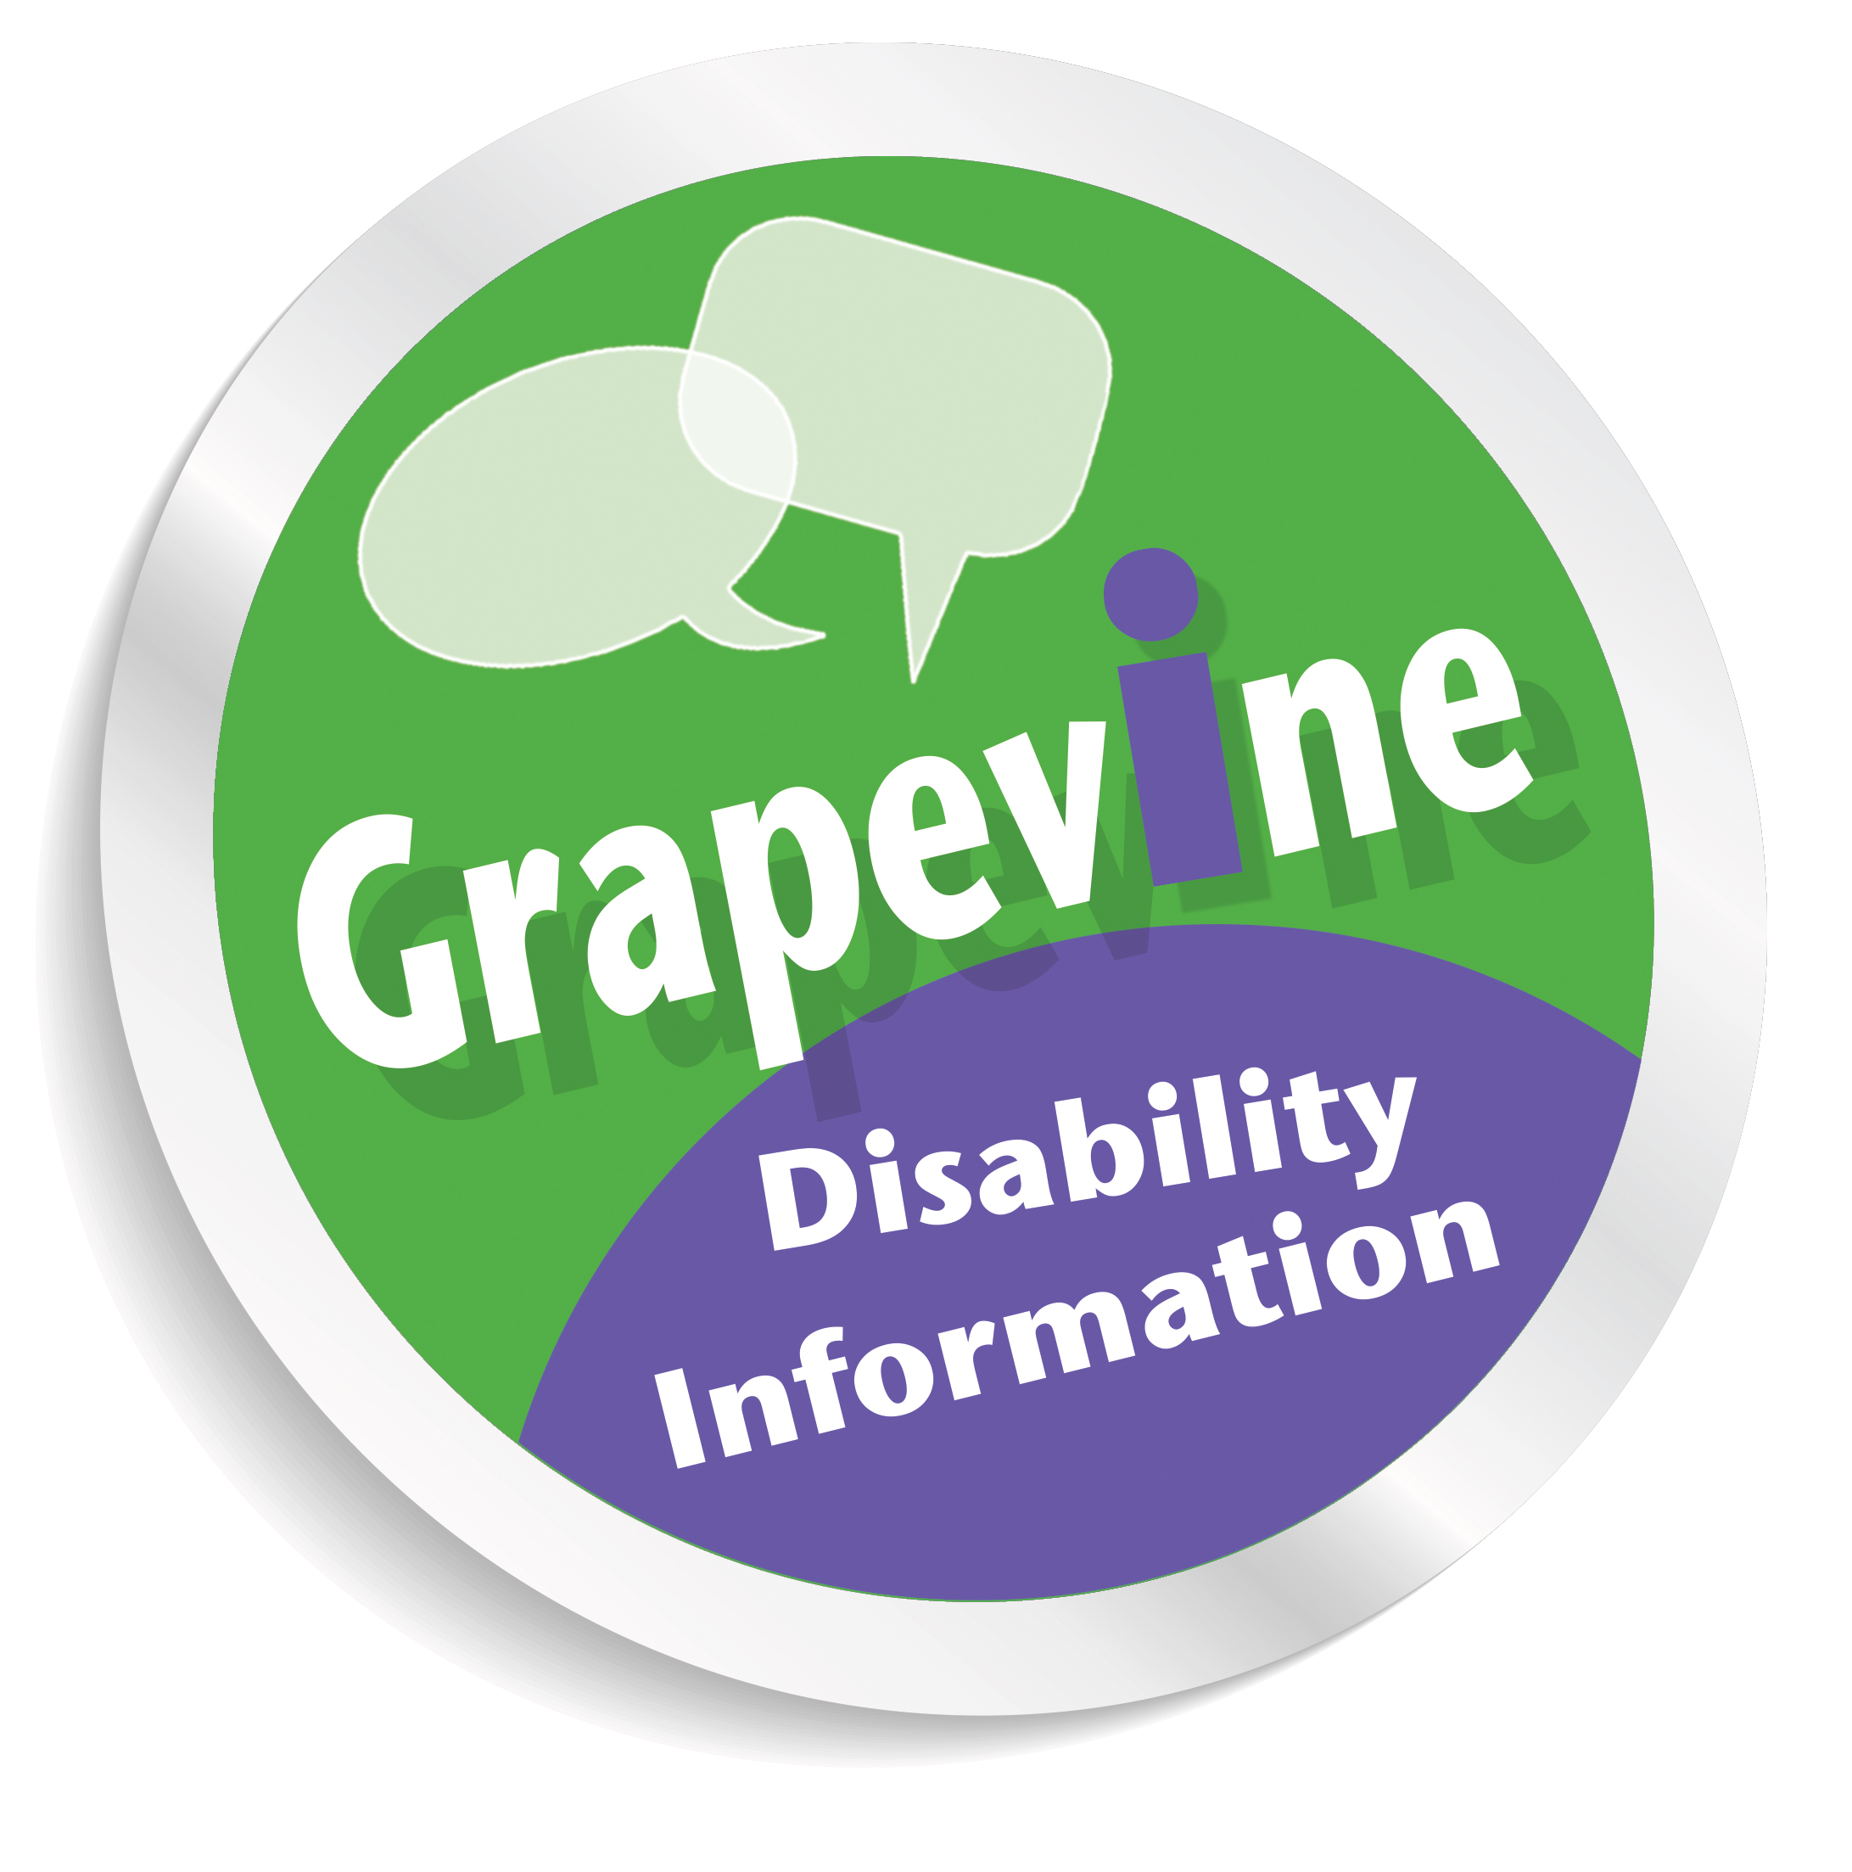
Personal Independence Payment = delays for assessments

People making new claims for the disability benefit Personal Independence Payment (PIP) are waiting in excess of 6 months for face to face assessments as part of their claims. This means many individuals are waiting for months on end without payment of a benefit which is there to assist disabled people and people with long term conditions live independently. It also acts as a pass-port onto other essential help and assistance such as transport concessions and Carer’s Allowance, depending on the rate of award.

Reports have surfaced recently which said that by December 2013 there had been 229, 000 claims but only 43,800 decisions for PIP. One of the reasons for the delays seems to be the time it is taking to do the assessments. Once people complete the PIP claims form ‘How Your Disability Affects You’ it is sent back to the Department of Work and Pensions (DWP) and claimants receive letters to invite them for a face to face assessments by an independent health professional. A decision is then made by the DWP on the rate of benefit. The payment will be back-dated to the date of the initial phone call to start the claim for PIP; however in the meantime people have to rely on other sources of financial help and means-tested benefits.

PIP was introduced one year ago for all new claimants in Scotland as part of a 5 year planned replacement for Disability Living Allowance (DLA) taking it up to 2018. Disability Living Allowance (DLA) claimants who did not reach their 65th birthday by the 8th of April 2013 will be reassessed at some point with a random national selection of reassessments starting in October 2015, as things stand just now.

Grapevine the disability information and service for people living in Edinburgh, Midlothian and East Lothian can assist people with claim forms and inform people on their entitlement to the benefit. We also advise people on other benefits and other help available based on the rate of entitlement to PIP.

If you need advice or information about claiming PIP, and what other help and assistance you may be entitled to receive call us on 0131 475 2370 or email: grapevine@lothiancil.org.uk

What you can do:
If you have your own story to tell in relation to claiming PIP you can make sure your views are listened to:

The Scottish Parliament’s Welfare Reform Committee are seeking people with experience of Personal Independence Payment to tell MSPs their story, If you are a person who has been assisted by Grapevine with a PIP claim then please contact us to let us know your experience so we can feed this back along with the other individual comments we have been receiving (for contact details see above). For those wanting to feedback their experience of PIP directly to the Scottish Parliament they can do so by emailing the Committee at WelfareReformCommittee@scottish.parliament.uk or writing to it at the Scottish Parliament at: The Scottish Parliament, Edinburgh, EH99 1SP

The national Disabled People Organisation Inclusion Scotland is also looking for people to talk about their experiences of applying for PIP. Email Rosalind Greig, at rosalind@inclusionscotland.org or call her on 0131 281 0865 to take part in her study which is using the experiences of people across Scotland.

Grapevine new factsheets:
- VAT Guide for disabled people – information on VAT relief and eligibility.
- Factsheet – Benefits and work – how benefits can be affected by working
Call us on 0131 475 2370 or email: graepvine@lothiancil.org.ukto receive a copy.


New benefit phone numbers:
The Department of Work and Pensions (DWP) have recently changed some of their numbers for benefit claimants, including those using Access to Work. They are:

Personal Independence Payments (for starting a new claim): 0800 917 2222
Personal Independence Payment helpline (for existing claimants): 0345 850 3322

Attendance Allowance: 0345 605 6055

Disability Benefits Helpline (e.g. severe disability premium, Employment Support Allowance): 0345 712 3456

Disability Living Allowance (existing claims only): 08457 123456

Access to Work: 0345 268 8489 or 0845 268 8489.

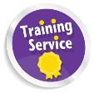

Training and Learning Opportunities
Training for Personal Assistants (T4PAs)

LCiL is running a two day training course for Personal Assistants or those who are thinking about becoming Personal Assistants which are ILA Scotland Accredited!!!!

A limited number of FREE places are also available for those who cannot access Individual Learning Accounts.

The topics covered include:


- Disability and equality - cultural representations of disabled people and barriers faced by disabled people
- Social Model of Disability – and how to apply the principles in your PA role
- Understanding the importance of appropriate language
- Exploring roles and relationships
- Knowing the relationship boundaries
- Exploring potential dilemmas
- Responding to your employer’s needs
The next confirmed date LCiL is running the T4PA Course at Norton Park, Edinburgh are: 24th and 25th June from 10.00am to 4.00pm (Lunch provided)
Want to know more about the course or ILA Eligibility? Contact us on the details below.

Tel: Amanda Beech on 0131 475 2350 or email: amanda.beech@lothiancil.org.uk

Introductory Health & Food Safety Course

LCiL in partnership with Greggs the bakers is offering another free training session for disabled people who want to learn about food safety and preparation skills. Topics covered include:
- Bacteria and causes of food poisoning
- Personal hygiene and hand washing
- Storage of food and kitchen safety
- Choosing the healthy option and more!

Dates: 16th June 2014 and more dates to come
Time: 11.30am—3pm
Venue: Greggs Bakery, Greggs Bakery, 36, Dryden Rd, Bilston Glen Industrial Estate, Midlothian EH20

Book your place now to guarantee your place! You will be contacted as soon as dates are confirmed!
Phone: 0131 475 2350
Email:amanda.beech@lothiancil.org.uk
Book online: http://www.lothiancil.org.uk/training-courses-booking-form/
Transport costs provided on request Refreshments provided by Greggs




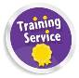


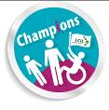
Happy 1st birthday to LCiL Champions!

The LCiL Champions programme is one year old on 4 June, and a video has been made showing how the Champions work. This will be available soon to watch on the LCiL website at: www.lothiancil.org.uk and is currently available at: https://vimeo.com/97253761
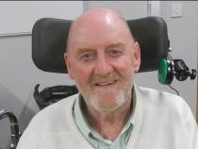
Robert MacPherson (in the photo) talks about his experience as a Champion:

‘My first year as an LCiL Champion has been, on a personal level, enlightening, educational and very enjoyable.

We’re a group of people with differing opinions, differing interests and differing competencies, but we’ve developed as a group, learned from each other and become friends. I’ve had training on so many things – what LCiL does, legislation, benefits, disability rights and how to prepare to speak to people – all very enlightening.

It’s been a great way to influence people on key decisions around implementing Self Directed Support simply by talking about my own experience of support.

I’ve spoken at a number of events, but two stick out as my favourites. Firstly, talking to a group of managers from older people’s services about the service I get from the council (despite the fact that I don’t see myself as an ‘older person’!) – They listened, asked really good questions, and obviously wanted to use what I was telling them to make improvements. That allowed me to speak very openly and frankly. Secondly, I gave the talk at ‘pause for reflection’ at City of Edinburgh’s full council meeting. I particularly enjoyed this as my dad was a councillor, and sat in that very chamber in the 1950s and 60s!

Looking ahead I feel that as Champions we must get even more involved in trying to influence local and national government to the benefit of other disabled people, and I hope when other organisations see the Champions video they decide to do something similar.’

LCiL’s Access to Work Resource:

Over 2013-14 LCiL was funded by the Office of Disability Issues (ODI) to promote and provide information sessions on Access to Work to disabled people, people with long term conditions, employers and employment support organisations, in Edinburgh and the Lothians.
Now that project reaching the final stages LCiL has built up a bank of resources on Access to Work for disabled people and support organisations, including employers, available to access to free in our online E-library: http://www.lothiancil.org.uk/downloads/access-to-work/
This includes accessible versions of Access to Work factsheets, a storyboard on a person’s journey to get support it and forms for people to use.
If people have individual enquiries about Access to Work they can contact the central UK phone number for the scheme on 0345 268 8489 or 0845 268 8489.

Alternatively disabled people living in Edinburgh, Midlothian and East Lothian can contact Grapevine the disability information line on 0131 475 2370 or email us at: grapevine@lothiancil.org.uk if they have general enquiries relating to the Access to Work and other employment/workplace issues.

Other News and Events:

Paid Internships for disabled graduates

Inclusion Scotland is working in partnership with the Scottish Disability Equality Forum (SDEF) to support a project creating and placing 75 disabled graduates in third sector organisations for focussed paid internship opportunities.

Taking part in one of these placements interns will carry out a piece of focussed project work that could make a real difference to the organisation they work for, and be paid while they develop their CV, their skills and build their confidence to seek work in the future.

Eligibility:

To apply as intern you must define yourself as disabled under the Equality Act 2010, be currently unemployed and in receipt of out-of-work benefits, and be a graduate of an HND, degree or equivalent qualification (SCQF level 8 or above).

How to apply:
The process of applying for this scheme goes via Job Centre Plus advisors, so before you can apply you must be registered with them as unemployed and in receipt of a relevant benefit such as Job Seekers Allowance (JSA) or Employment Support Allowance (ESA). If this does not apply to you, support is available to help you sign up in order to apply to opportunities in this programme as they become available.

Whether you are a potential intern or an organization, to find out more:

Get in touch with SCVO at equalityinterns@scvo.org.uk or call: AnnMarie Anderson or Moira Cuthbertson at SCVO on 0141 559 5006

Alternatively you can contact Phyl at Inclusion Scotland at phyl@inclusionscotland.org or 0131 281 0864
OR SDEF at adam.nosal@sdef.org.uk or 01259 272064

Further information for potential applicants is on the SCVO website here: http://tinyurl.com/o9yjs89


For those with a specific interest in politics, policy or public affairs…

Inclusion Scotland also has a Scottish Parliamentary Internship Pilot Programme for Disabled Graduates. Seven disabled graduates will be placed with MSPs from a range of parties, and carry out specific project work as well as general support to an MSP office, with opportunities provided to learn about the workings of Parliament, its committees and working groups.

The first intern is already in post with James Dornan MSP, who has been working to make the project a reality. They are now in the process of identifying the remaining six MSP hosts and expect to advertise the internship opportunities in early-mid June via Goodmoves, social media and email networks. If you would like to register interest in being directly contacted when these go live, please contact Phyl at Inclusion Scotland on 0131 281 0864 or e-mail phyl@inclusionscotland.org

Both the above schemes are funded by the Scottish Government.


Have your say on Disability

A national survey has been launched to find out what you think has changed for disabled people and people with long term conditions and what still needs to change to make life better in Scotland.
‘Your Say on Disability’ is a questionnaire which has been developed to inform the United Nations (UN) Committee of what disabled people and those with long term conditions feel about what is happening in Scotland with regard to disability, Independent Living and other disability related issues.

By completing this short online survey you can add you voice to share the future of a fairer and more inclusive Scotland. The findings from it will be feed via the Scottish Government to the UN when they review the UN Convention on Rights of Persons with Disabilities (UNCRPD) on how this has been implemented in Scotland over the next year or so.

You can find out more by visiting: www.your-say-on-disability-org.uk

Other formats are available from this link or you can call the Scottish Disability Equality Forum on 01259 272064 for a copy.


Referendum, referendum, referendum!
Learning Disability Alliance Scotland (LDAS) has published two new Easy Read documents on the arguments for and against an Independent Scotland. They are aimed at helping people with learning disabilities make up their mind about what they would like to do in the referendum on September 18th 2014.

The first is from the Better Together campaign and summarises the reasons why Scotland should stick together with the rest of the UK.
The second is from the Scottish Government and summarises the White Paper on Scotland.
Both can be found on the Disability Resources section of the E-library on LCiL’s website at: http://www.lothiancil.org.uk/e-library/ or at LDA’s website at http://www.ldascotland.org/index.php/information/121-new-easy-read-documents-on-the-referendum
Future of the welfare system: Glasgow Disability Alliance (GDA) have also produced two easy read briefings in word and PDF format on the Scottish Referendum debate and extracted the section on Welfare Reform from the Scottish Government's White Paper on Independence and the Better Together’s campaign a factsheet on the welfare system. These are also available to download from the Disability resources section of the E-library at: www.lothiancil.org.uk or at Glasgow Disability Alliance website at: http://www.gdaonline.co.uk/showlog.php?weblogid=294

Midlothian Stress Control Classes

A free 6 week evening class designed to help you cope better with stress in your life is available in Midlothian. It is running on Tuesday evenings from the:
17th June - 22nd July 2014 6.30–8.00pm
The Lasswade Centre - Lasswade Library
19 Eskdale Drive, Bonnyrigg - EH19 2LA

To book a place or for more information contact: Information Resource Centre, Health in Mind, Telephone 0131 243 0106 10am–4pm
(Answer machine service available) or e-mail contactus@health-in-mind.org.uk


Home2Fit – Scotland’s Accessible Housing Register

Home2Fit – Scotland’s Accessible Housing Register is a new innovative web based system which will help disabled people in housing need by offering a matching system between disabled people and adapted wheelchair accessible properties – a bit like a dating site. Home2Fit also offers the opportunity to develop a national register of adaptations and accessible properties which can be built up over time helping to improve the efficiency of managing adaptations and helping to ensure that the right house goes to the right person at the right time.

Glasgow Centre for Inclusive Living (GCiL) are now piloting the new service and it’s likely LCiL will be working with them to ensure those in Edinburgh and the Lothians can access housing which they need via local housing stock.

A full national launch is being planned for later in 2014/15. Watch this space! For more information please contact Grant Carson, at Glasgow Centre for Inclusive Living on 0141 550 4455 or email: grant@gcil.org.uk or visit: http://www.home2fit.org.uk/

NEW Volunteering opportunities:
Canal Community Connections is a new project linking two canal communities: Falkirk and Wester Hailes (Edinburgh). They have a range of volunteering positions available which will offer participants the opportunity to experience handling and maintaining a narrowboat and learn a range of related skills. What’s involved?

- Weekly training activities – learn at your own pace
- Learn to drive the boat and work towards Royal Yachting Association certification
- Learn to crew the boat for group bookings
- Crew skills: health & safety, water safety, first aid, hospitality, food hygiene
- Boat skills: general and engine maintenance, boat painting, rope work, set-up for trips
- Canal skills: how canals work - locks, aqueducts, Falkirk Wheel; canal heritage and environment, conservation, John Muir Award
For more information contact Jenny on 0131 261 8529 or email:
jenny@re-union.org.uk


Key-Comm - Lothian Communication Technology Service

KEYCOMM exists to help people with communication impairments make use of technology to contribute and control their environments.
Based in Edinburgh they can recommend appropriate technology and support for Alternative and Augmentative Communication (AAC) i.e. to assist with speech or add onto speech. They also provide training and information for users, carers/family members and workers on how to use and apply certain technology based on their individual needs.
This includes a Loan Bank of equipment, which individuals living in Edinburgh and the Lothians can access. Low tech, mid tech and high tech materials and communication aids to support communication are available, including computers, devices and materials.

Anyone of any age can refer onto the service. You can download a referral form from their website at: www.keycomm.weebly.com or by calling 0131 311 7130.

Compare energy prices with Which? Switch
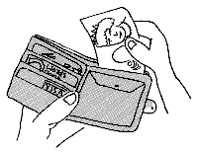
‘Which? Switch’ is an online energy supplier switching service brought to you by Which? the UK’s consumer association.
Which? Switch was launched to provide consumers with a transparent and impartial way to compare energy tariffs and find the best gas and electricity provider for your needs. If you want to compare your energy prices to see if you’d be better off swapping then visit: https://www.which.co.uk/switch

Changing Places toilets in Scotland

Changes Places Toilets are specifically designed for people who require assistance to change. PAMIS have been campaigning for these toilets to be available across Scotland and in all new larger buildings and complexes such as shopping centres, sports centres, etc. They have a directory which lists all accessible changing places across Scotland which can be downloaded for free from the website at: http://pamis.org.uk/cms/files/changing_places_toilets_in_scotland-final.doc.pdf
Or you can call them for a copy on 01382 385 154

Midlothian benefits cuts group:

Since the start of the year a group of individuals concerned with aspects of welfare reform which are hitting disabled people hardest have been meeting in Midlothian. This is primarily for disabled people and people with long term conditions who are personally affected by some of the changes. The group offers a confidential space to share experiences with others and get information, advice and support from workers who are available to offer this on an individual basis should it be required.

The next meeting is due to take place on Tuesday 8th of July 2014 from 11am at the Arts Centre in White Hart Street, Dalkeith. For more information contact Kirstie at Grapevine on 0131 475 2370 (Mon-Thu, 10am-4pm) or email: grapevine@lothiancil.org.uk alternatively call Eric Johnston at Forward Mid on: 0131 663 9471

National survey of wheelchair users:

A national survey aimed at wheelchair users in the UK has been launched to find out
about experiences of:
- getting information and advice on choosing a powered wheelchair;
- the assessment process;
- funding for a powered wheelchair;
- maintenance and after-sales service ;;;
- any barriers experienced
The survey is being conducted in partnership with a range of charities including: Disability Rights UK, Muscular Dystrophy Campaign, Scope, Spinal Injuries Association and Whizz-Kidz and aims to identify user priorities for future research work.

The survey will close on the 30th of June 2014: With a chance to win £50 in shopping vouchers, you can complete the survey here: www.rica.org.uk/PWsurvey

If you prefer, you can request a print copy from Rica:
Rica, G03 The Wenlock, 50-52 Wharf Road, London N1 7EU or phone: 020 7427 2460.

Grapevine Disability Information Service

Providing up to date, reliable and accessible information to disabled people and their supporters in Edinburgh, East Lothian and Midlothian. We cover all disability related matters and our service is completely free and confidential.

You can contact us on:

Disability Information line 0131 475 2370 (Monday – Thursday, 10am-4pm)

(If you can’t get through to speak to someone please leave a message on the answer machine and someone will call you back as soon as possible).

Alternatively you can email your enquiry to: grapevine@lothiancil.org.uk

Or use our Online enquiry form at: http://www.lothiancil.org.uk/

Appointments can be offered to disabled people living in Edinburgh, who require assistance on their Personal Independence (DLA) and Attendance Allowance (AA) forms.

Check out the latest news on our website at: www.lothiancil.org.uk
Or write to Grapevine, LCiL, Norton Park, 57 Albion Road, Edinburgh, EH7 5QY.

To contact the Lothian Centre for Inclusive Living (LCiL) please call our main switchboard number on 0131 475 2350 (available Mon-Fri, 10am-4pm or email: lothian@lothiancil.org.uk)

Other helpful phone numbers:
It is a good idea to keep these numbers where you can find them when you need support or help. Services such as Breathing Space and the Samaritans offer a listening service to people who are suffering from emotional stress. Social Work and the NHS are more appropriate if you need more than this.

Breathing Space - 0800 83 85 87(Mon to Thurs 6pm - 2am) (Fri to Mon 6pm - 6am)
Samaritans - 08457 90 90 90 (24 hours)
Emergency Social Work Service - 0800 731 6969 (out of hours only)
NHS 24 Helpline (111)
NHS Inform Helpline – 0800 22 44 88 (8am to 10pm, 7 days) - can give you details of all pharmacies, GP practices and dental practices in Scotland.

This publication is available on request in a range of alternative formats, including Large Print,  Audio Tape  and Braille. 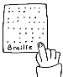
Audio

The Lothian Centre for Inclusive Living (LCiL) is a Company Limited by Guarantee Registered in Scotland 129392. Scottish Charity No SC017954. Copyright © 2014 LCiL. All Rights reserved.

