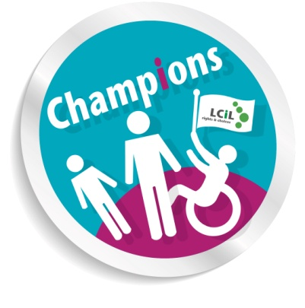MC900351591[1]

LCiL Champions are available to share their lived experience at conferences, events or training programmes, or to become members of working groups or committees.

**For more information about the LCiL Champions,** or to discuss the possibility of having a Champion participate at an event or meeting in your area, contact Debbie Bayne:

**0131 475 2628**

[debbie.bayne@lothiancil.org.uk](mailto:debbie.bayne@lothiancil.org.uk)

**Lothian Centre for Inclusive Living**

Information is available on request in a range of formats:

**Audio Braille Easy words Large Print**

For more information about LCiL services, contact:

0131 475 2350

[lcil@lothiancil.org.uk](mailto:lcil@lothiancil.org.uk)

[www.lothiancil.org.uk](http://www.lothiancil.org.uk)

Lothian Centre for Inclusive Living

Norton Park, 57 Albion Road

Edinburgh, EH7 5QY

(our offices are fully accessible, with parking available)

**Getting in touch**

**Let’s tell it like it is –**

**The LCiL Champions programme**

LCiL is a registered charity number SC017954

Pictures from CHANGE Picture Bank & London People First

Nine disabled people, people with long term conditions or carers who are involved with LCiL and its services in a variety of ways.

They’re volunteers who’re trained, equipped and supported to carry out their role – each one has a member of LCiL staff as a Buddy, and they meet together regularly as a peer support group.

**Who are the LCiL Champions?**

We will match you with the right Champion – they have a variety of experience and will tailor their input to your needs.



We have funding to cover expenses for a Champion to come to your meeting or event.

Please see over for how to get in touch.

**What do they do?**

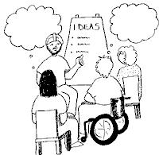

Working mainly across Edinburgh and the Lothians, Champions share their lived experience of independent living, self-directed support, LCiL and its services, disability rights and the social model of disability. By doing this they can:

LCiL works with disabled people, people with long-term conditions and older people, parents and carers in Edinburgh and the Lothians.

We support people to take control of their own lives, support their choice to take up their rights and enable their full participation in society,

and to:

* live more independently
* be more in control
* use self-directed support

**About LCiL**

* raise awareness and understanding
* act as role models
* work as co-production partners

to help:

* test new ideas
* create new policies
* design new or

improved services