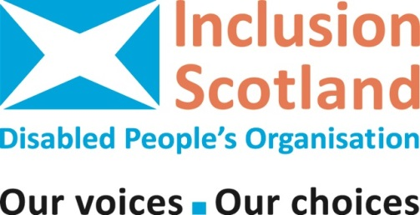
Keep in Touch

Gathering our members’ views
Access to Edinburgh Waverly station made more difficult for disabled people

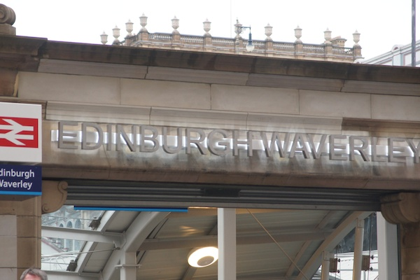
Inclusion Scotland has been getting a lot of reports about the difficulties disabled people have been experiencing since Network Rail closed Edinburgh Waverley station to all vehicles on 2nd June 2014.
We think what Network Rail has done is unacceptable.
We want to challenge the closure on behalf of the many disabled travellers (among others) who will be badly affected – and we need your help.
Full information on the story and all changes to Edinburgh Waverly can be found on our website: http://inclusionscotland.org/news/story.asp?id=7474

What’s the problem?

Edinburgh Waverley is a large transport hub. It is not only disabled people living in Edinburgh and the surrounding towns that are affected by these changes. Disabled people all over Scotland will pass through it at some time or other.

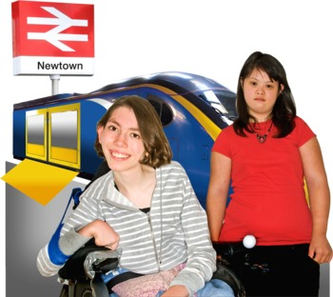
Also, it is not only Scottish people that use the station. Scotland is a major tourist destination. Disabled people from all over the world need to have confidence in our transport system. This year Scotland is hosting the Commonwealth Games, Ryder Cup and other events. We also have yearly events taking place such as the Edinburgh Festival and T in the Park amongst others. Therefore, it is imperative to ensure that the station in our capital city is accessible to all.

Why have Network Rail done this?

Network Rail has given the following reasons for making the changes to Edinburgh Waverly:

- Security – particularly the threat of terrorism

- Passenger safety – decreases the risk of someone being knocked down

- Air pollution due to exhaust fumes

However cynics might wonder whether it’s really because they think they’ll make more money by installing shops where the taxis used to go.
What Inclusion Scotland has done so far

We have already put out a call for a response to the changes through our membership and social networking sites.

Some points disabled people and their organisations have already raised include:

- Only one of the three station entrances has an intercom which you can buzz for assistance

- The assistance office isn't well signposted and is really difficult to find

- The taxi ranks on Waverley Bridge and Market Street have no protection from the elements and no seating

- Vehicle free zones are a nightmare if you can’t walk any distance

- Changes have done nothing to improve access to the station and a great deal to make it worse

- Anyone not already very familiar with the station layout stands little chance of finding their way around. Anyone with a visual impairment, limited mobility - or just heavy luggage - is likely to have a particularly difficult time.
We have been writing letters, expressing concerns and asking questions about the changes. People we have sent letters to are:

- Network Rail
- Department for Transport
- Scottish Government
- City of Edinburgh Council

We copied our letters to the following groups:

- Scottish Accessible Transport Alliance
- Mobility and Access Committee Scotland
- Equalities and Human Rights Commission

We want to meet with the people who have power to change this awful situation. We want to collect more evidence to make as strong a case as possible. This is where we need your help.

How you can help
Inclusion Scotland calls upon Network Rail to put passengers before profit. The complete indifference – bordering on contempt - they have shown to the needs of their many disabled or elderly passengers cannot be allowed to go unchallenged.

Some of your members may already have travelled to or through Waverley Station recently. They may have experiences they could share with us. Here are some questions you might like to ask your members.

- Have any of your members tried to access Waverley station recently? If so, did they have any problems with access? Would they like to tell us more about their experiences?

- What facilities could Waverley station have available to make your members journeys/experience of the station easier?

- Is there anything that you would like to do on this issue that Inclusion Scotland can publicise for you?

Please do let us know what they say. We will make sure we do not reveal the identity of anyone.

Please send all responses to these questions to Sue Kelly by Friday 4th July: sue@inclusionscotland.org or telephone Sue on 0131 281 0866.

You can also send us a message on Facebook: http://www.facebook.com/InclusionScotland Or send us a tweet: https://twitter.com/InclusionScot
Further information

If you are seeking more information about how to access Edinburgh Waverley station following these changes you can call Network Rail’s 24 hour Helpline on 08457 11 41 41.

If you feel you have faced discrimination when accessing Edinburgh Waverly you can contact the Equality Advisory Support Service. They are a national helpline which is able to advise individuals on issues relating to discrimination and human rights. They can be contacted on 0808 800 0082.

