**Getting in touch**

**For more information about Independent Living Support,** or to arrange to meet an Independent Living Officer, contact:

**Tel: 0131 475 2350**

(Monday - Friday, 10am - 4 pm)

**Email:** [ilteam@lothiancil.org.uk](mailto:ilteam@lothiancil.org.uk)

Support can be arranged at our office,

as a home visit or at another appropriate or accessible venue.

For information about all of LCiL services, visit our website: [www.lothiancil.org.uk](http://www.lothiancil.org.uk)

 Find us on Facebook  
 Follow us on Twitter

Lothian Centre for Inclusive Living, Norton Park, 57 Albion Road, Edinburgh, EH7 5QY (Our offices are fully accessible, with parking available)

Information is available on request in a range of formats:

**Audio Braille Easy words Large Print**

MC900351591[1]MC900351591[1]

Information is available on request in a range of formats:

**Audio Braille Easy words Large Print**



Information is available on request in a range of formats:

**Audio Braille Easy words Large Print**

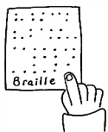MC900351591[1]

MC900351591[1]MC900351591[1]

MC900351591[1]

Information is available on request in a range of formats:

**Audio Braille Easy words Large Print**

**Independent Living Support**

LCiL is a registered charity number SC017954

Pictures from CHANGE Picture Bank & London People First

LCiL is a registered charity number SC017954

Pictures from CHANGE Picture Bank & London People First

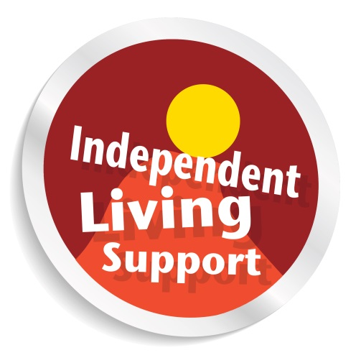

MC900351591[1]

MC900351591[1]

If you’re a disabled person or someone with a long-term condition and interested in self-directed support, LCiL’s Independent Living Team provides information, advice and one-to-one support for you to:

* Explore your options of support
* Decide who provides your support and when
* manage your self-directed

support package



**Lothian Centre for Inclusive Living**

MC900351591[1]

**Training**

**What do we offer?**

LCiL also offers **free training opportunities** to support people to employ PAs,

including:

* Essential Employer’s

Skills Training

* Living and Work

Choices

* Training for PAs

Training is accessible,

flexible and is devised and delivered by disabled trainers.

Your **Independent Living Officer** can support you to:

* identify and express your needs and outcomes
* prepare for your local authority assessment
* explore which SDS option is best for you
* liaise with local authorities and other appropriate organisations
* contract with an agency
* recruit and manage personal assistants (PAs):
* draw up job descriptions
* place adverts
* short list, interview and contract with staff
* Help with any other related queries

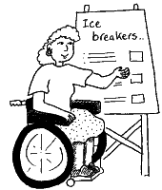

training



The Peer Support Group is an informal meeting where disabled people who employ their own PAs, or those seriously considering employing PAs, can share experiences and exchange ideas.

**About LCiL**

**Peer Support Group**

LCiL works with disabled people, people with long-term conditions and older people, parents and carers in Edinburgh and the Lothians.

We support people to take control of their own lives, support their choice to take up their rights and enable their full participation in society,

and to:

* live more independently
* be more in control
* use self-directed support