Updated ILF Scotland messages

ILF Scotland has employed a Chief Executive called Peter Scott.

For further information on this please go to http://news.scotland.gov.uk/News/Independent-Living-Fund-Appointment-181b.aspx

We have now employed:
- 6 Caseworkers
- Head of Operations
- Head of Appeals and Reviews
- Service Delivery Manager

We have started the recruitment for:
- Assessors
- Senior Social Work Practitioner
- Finance Manager
For further information on these jobs please go to http://www.brucetaitassociates.net/careers

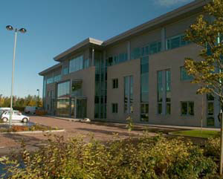
The team are now in their new offices at Denholm House, Livingston.

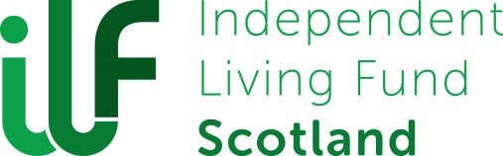
We would also like to draw your attention to the new ILF Scotland logo.

We worked together with service users and the project board to achieve this logo.

This was to make sure it was as accessible as possible and we are delighted with the final results.

Coming soon

Employment for the ILF Scotland’s board of Directors will start soon so please keep an eye on the website

A telephone contact number will be shared soon so please look at the website for further information.

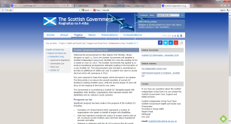
For further information please go to the website:
http://www.gov.scot/Topics/Health/Support-Social-Care/Independent-Living/ScottishIndependentLivingFund

Please get in touch on enquiries@ILF.scot

Many thanks from the ILF Scotland Team

