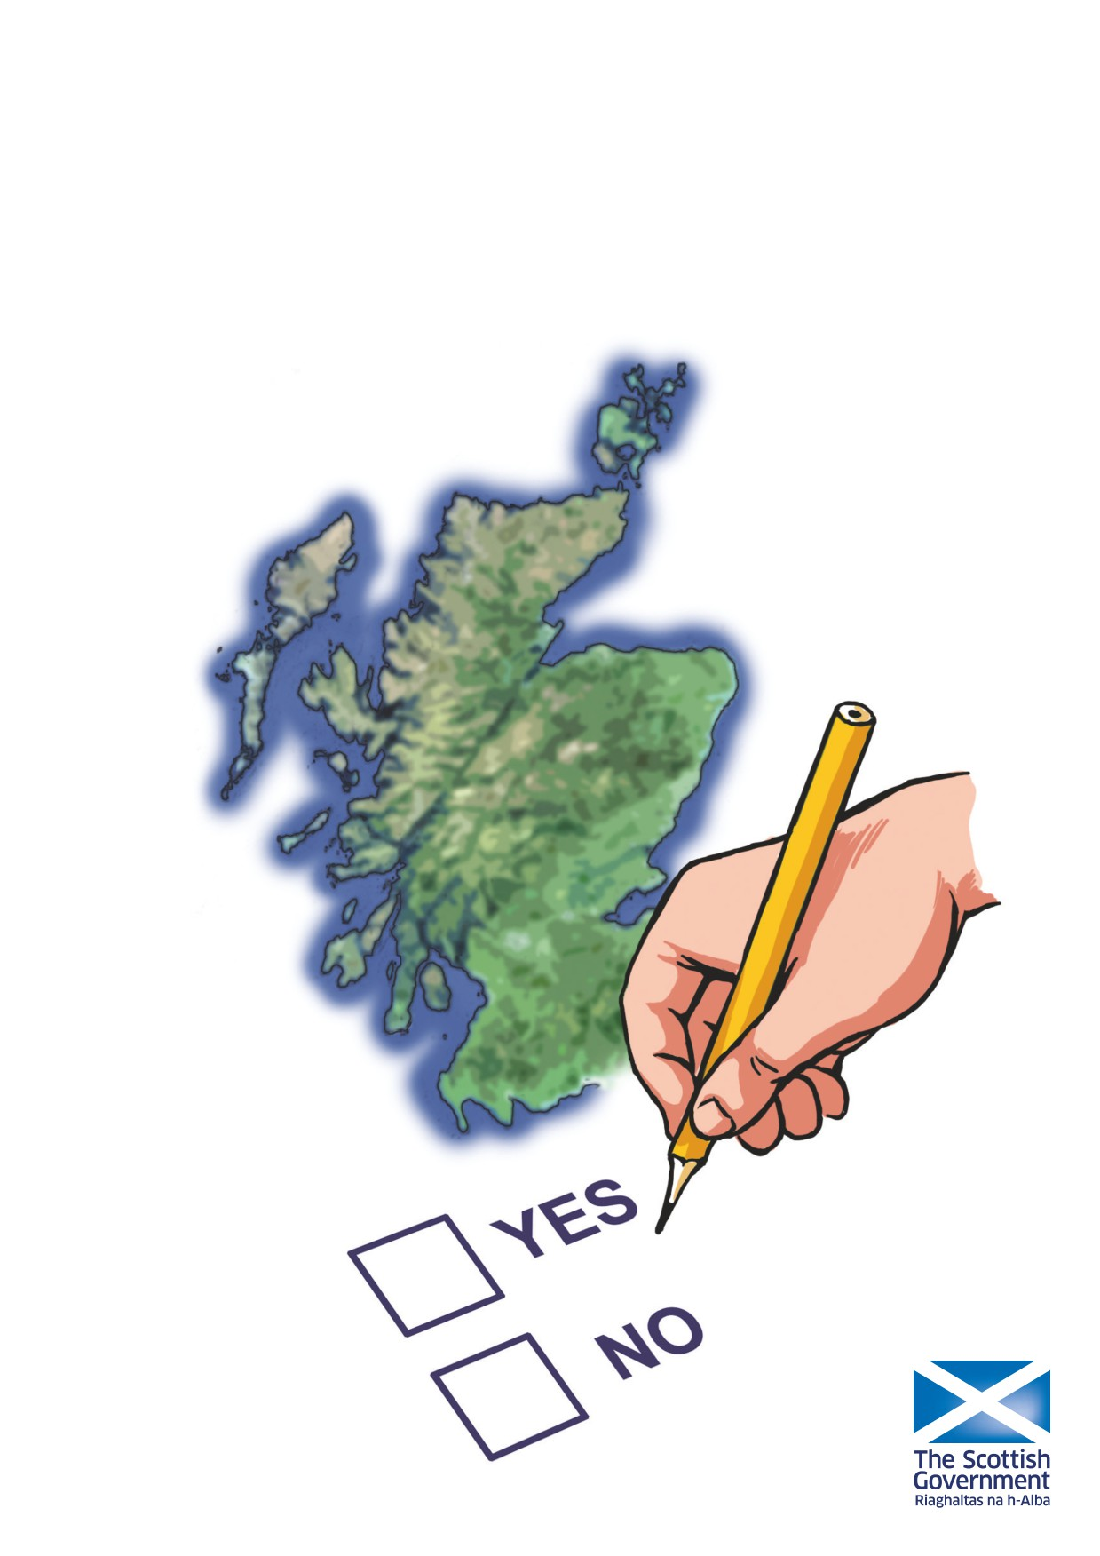
Scotland’s Future
Your guide to an independent Scotland
Easy Read Summary

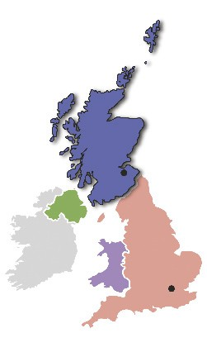
Scotland’s future is in your hands. This is a paper by the Scottish Government.
This is a guide to an independent Scotland.
Independence means that a country runs itself.

Scotland has its own Parliament but is part
of the United Kingdom (UK).This is called devolution.

The Scottish Parliament doesn’t make all
the decisions about how Scotland is run.

A lot of the important decisions about Scotland are made by the UK Government in London.

The Scottish Government doesn’t think devolution is enough for Scotland.
The Scottish Government thinks
Scotland should be independent.

All decisions about how to run Scotland would be made by the Scottish Government if Scotland was independent.

The UK Government thinks Scotland should not be independent.
Scotland

London

On 18 September 2014 the people of Scotland will vote.
They will decide if they want Scotland to become an
independent country or not. This vote is called a referendum.

The referendum does not ask you to choose a political party.
The referendum asks you “Should Scotland be an Independent Country?” You can answer Yes or No:
Yes - If you vote yes you want Scotland to become an independent country.
No - If you vote no you do not want Scotland to be an independent country.

1

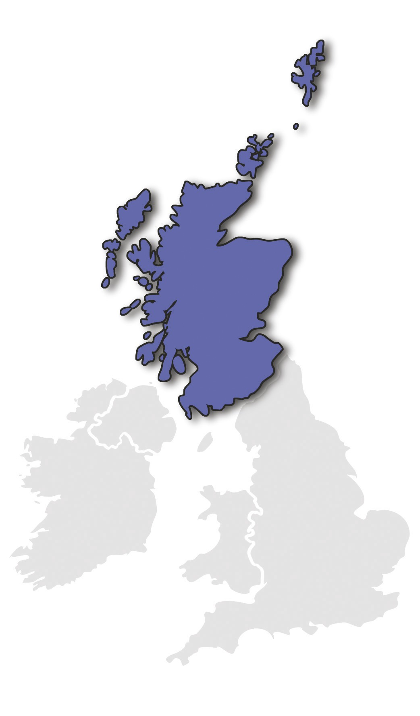
What independence will mean for Scotland

•

Decisions about Scotland will be made

in Scotland

•

An independent Scottish Parliament will

be voted for by people in Scotland.

•

An independent Scottish Parliament will

make decisions about everything, for example tax and benefits.

•

Scotland will be able to keep all public

services public. This means they will be
owned by the people of Scotland and
not by private companies. The NHS is a
public service.

•

Scotland will decide how the taxpayers’

money should be spent.

•

An independent Scotland can use the

money from oil for the future.

•

Scottish taxes will not be used to pay

for nuclear weapons and nuclear
weapons can be taken out of Scotland.

These things will happen if Scotland becomes independent. Decisions on other things will depend on who becomes the government in the future.
The first election in an independent Scotland will happen in May 2016 and the people of Scotland will be able to choose which party should become the government.

2

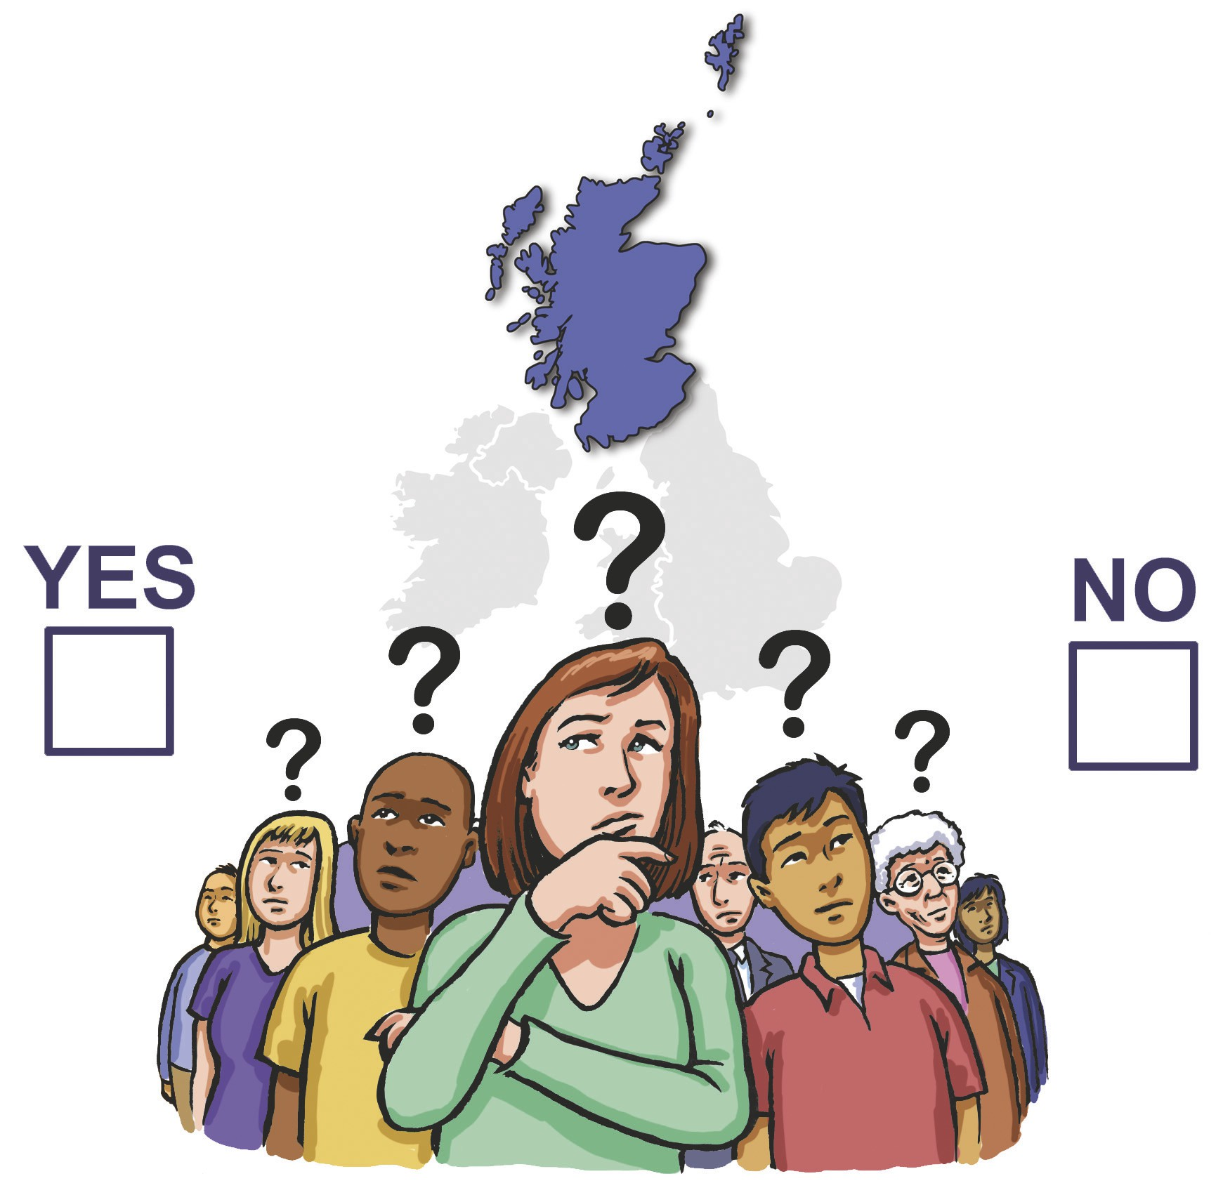
Why the Scottish Government thinks you should vote for independence

The Scottish Government wants Scotland to be independent:
• To make Scotland more democratic
Democratic means everyone gets an equal say in how a country is run.

• To make Scotland better off
Scotland is a rich country. Scotland pays more tax per person than the
rest of the UK. All decisions about Scotland’s money will be made in
Scotland and we think Scotland will be richer if it is independent.

• To become a fairer society
UK society is becoming more unequal. We think an independent Scotland will become more equal.
The Scottish Government think it is time for the people of Scotland to take charge of our own future.
3

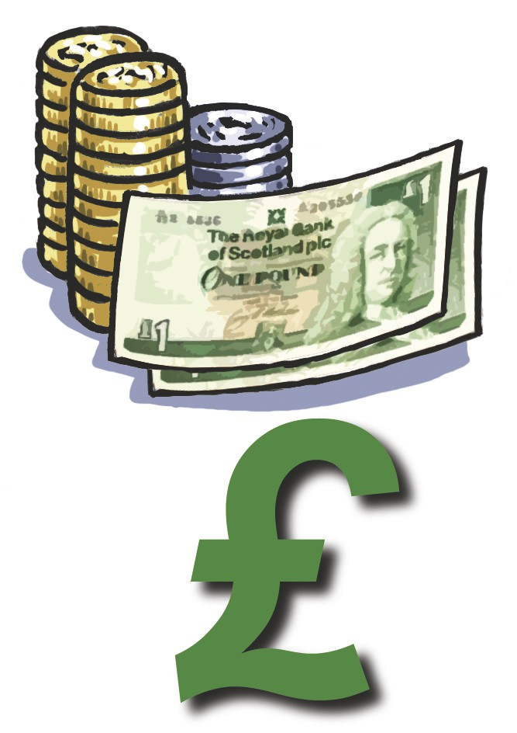
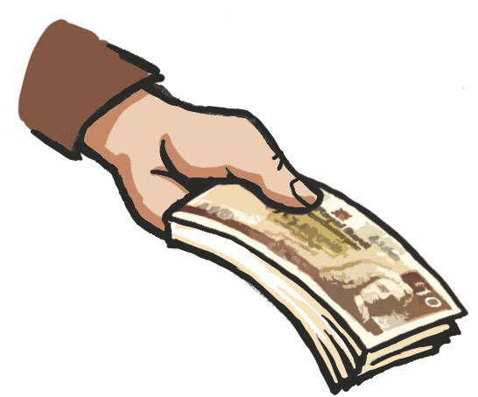
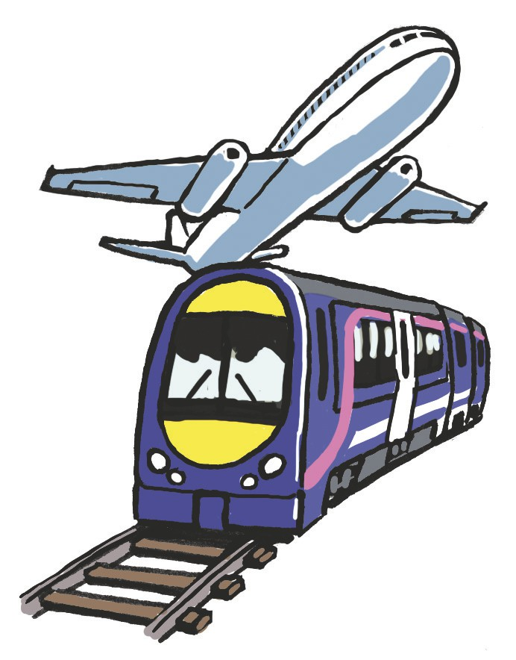
Why the Scottish Government thinks you should vote for independence

Money
Scotland is treated as a small part of the UK. With independence we will run our own country.
Independence will let us build a wealthier Scotland with more jobs.

We will keep the pound in an independent Scotland.

Taxes
Independence will let us make a Scottish tax system that works best for Scotland.

There will be no need for an independent Scotland to raise
more taxes than now to pay for the public services we have
now.

The way taxes are collected in Scotland is complicated. In an independent Scotland we will make this easier.

Transport
Good transport is very important for Scotland.
Independence will let us make more choices for our transport system.

4

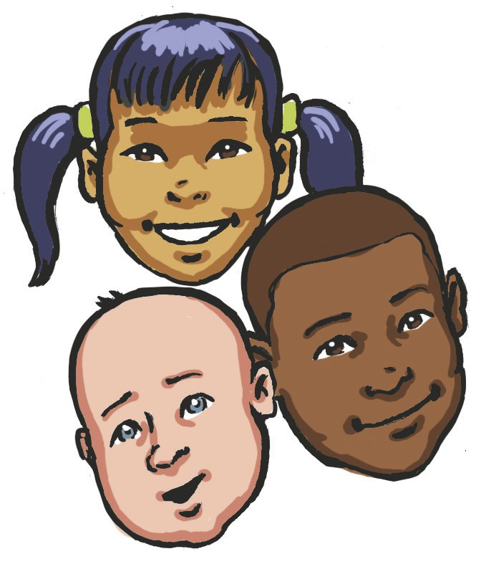
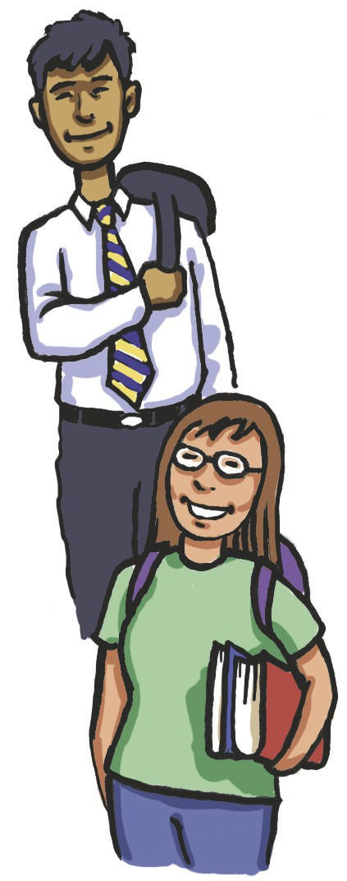
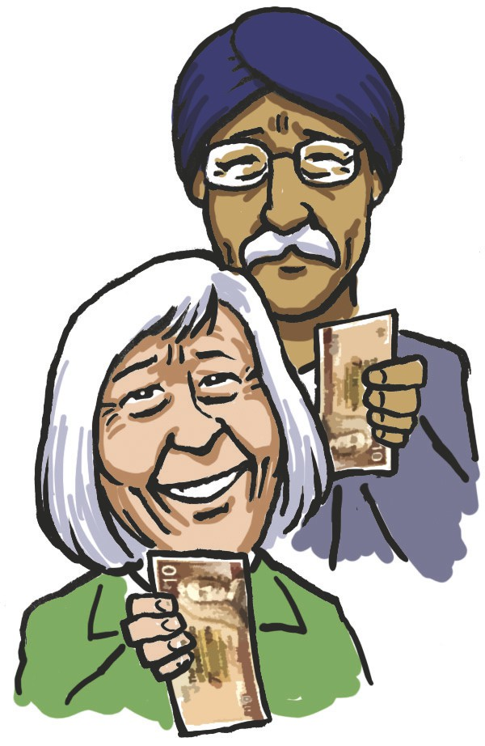
What the Scottish Government wants to do if Scotland becomes independent

Children
Parents in the UK pay some of the highest childcare costs in Europe.
Independence will give us the chance to make childcare services cheaper for people in Scotland.

Schools and universities
Children in Scotland’s schools have been doing better.
A lot of money has been spent on schools and new teachers.

But the poorest children don’t do as well at school as those who are better off.

Independence will give us the chance to do something about this gap and the reasons behind it.
Higher education will still be free if Scotland becomes independent.

Pensions
We will make sure that pensioners will get their pensions on time and in full.

We agree that the State Pension Age should rise to 66.
The UK Government want to put the State Pension Age up
to 67. We think experts should decide if this is right for
Scotland.

We want to make sure that all workers have a private pension.

5

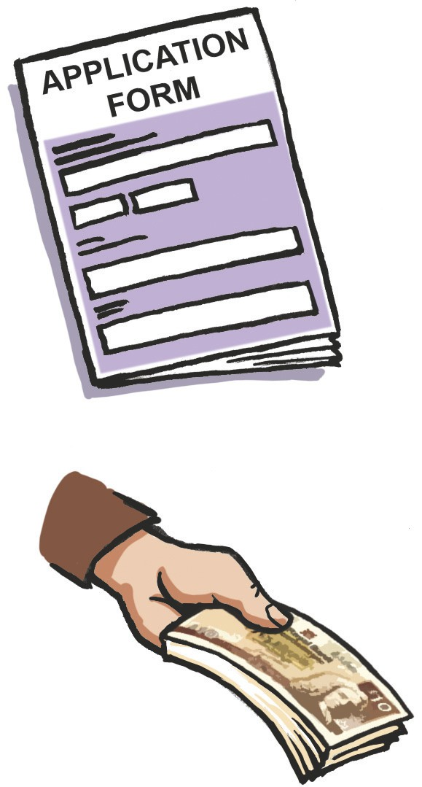
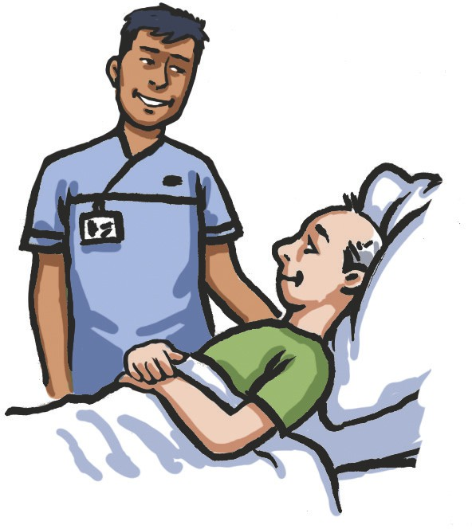
What the Scottish Government wants to do if Scotland becomes independent

Welfare & benefits
Scotland should have a welfare system that supports people
who work and is a safety net for people who cannot work.

We will undo the worst of the UK welfare changes if
Scotland becomes independent. On independence we will:

•

stop the “bedroom tax” which most Scottish people

think is unfair.

•

stop the roll out of Universal Credit and

Personal Independence Payments

•

make sure that benefits and tax credits go up to

the right level

Health
There will still be high quality health and social care if Scotland becomes independent.
Scotland can work towards a fairer society with equal health for all.

6

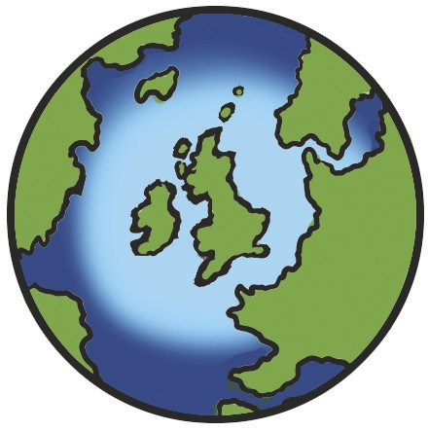
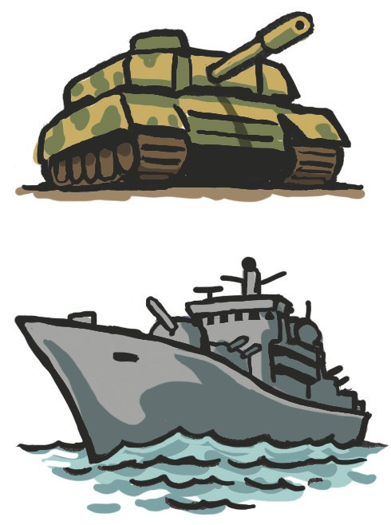
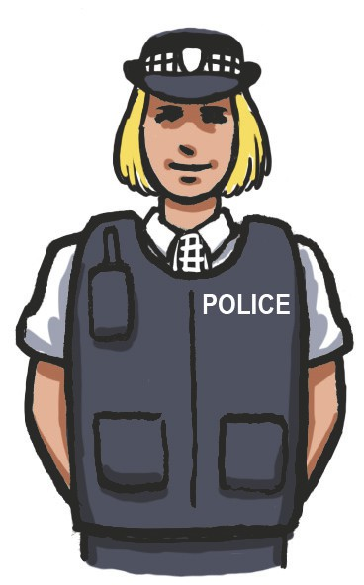
What the Scottish Government wants to do if Scotland becomes independent

Scotland’s place in the world
An independent Scotland will have strong partnerships with other countries.

Scotland and the rest of the UK will work closely together.

We want an independent Scotland to stay a member of the European Union (EU).

An independent Scotland will spend some of its money helping other countries.

Defence
We will spend enough on defence so we can have the armed forces we need.
We will remove nuclear weapons from Scotland if there is a vote for independence. We will find the quickest and safest way to do this.
We want Scotland to be part of NATO (the North Atlantic
Treaty Organisation) if there is a vote for independence.

Law and order
It is our poorer communities that suffer most from crime. We will deal with the causes of crime and not just the results if Scotland becomes independent.

We will make our communities safer and more secure.

7

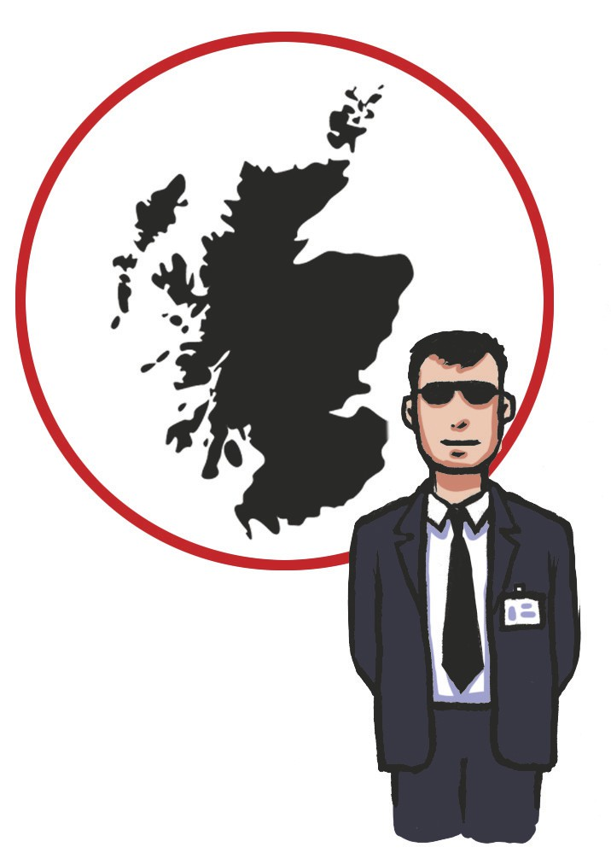
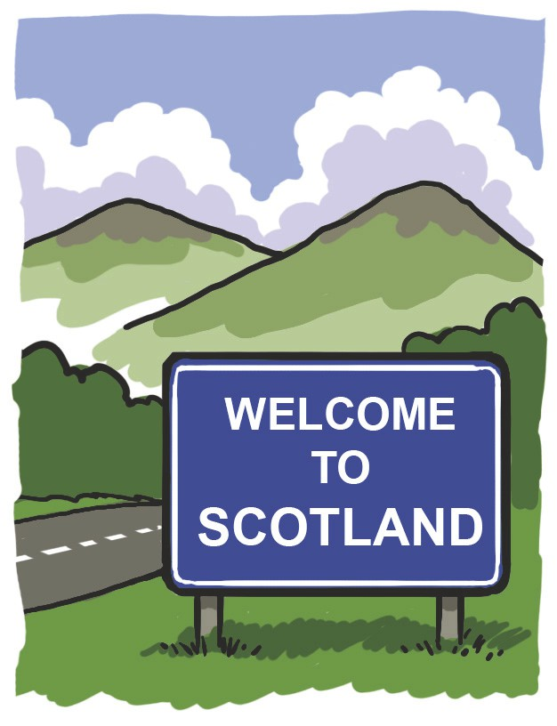
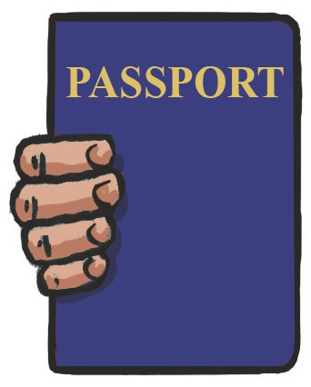
What the Scottish Government wants to do if Scotland becomes independent

Security

An independent Scotland will have a national security system that meets Scotland’s needs.
We will do a full review of our security needs. A new security
and intelligence organisation will be in charge of Scotland’s
security.
The Scottish Government will work closely with the rest of the UK to keep both countries safe.

Immigration

The UK immigration system does not work well for Scotland.
We want to make a new immigration system which will meet the needs of Scotland if Scotland becomes independent.

We will bring back student visas that the UK Government
did away with. This will mean that more talented people from
around the world will come to have their education in Scotland.

Citizenship and passports

Lots of people will become Scottish Citizens. British citizens
who live in Scotland will automatically become Scottish citizens if there is a vote for independence.

People born in Scotland living outside Scotland will also
become Scottish citizens if there is a vote for independence.
Other people will be able to apply to become Scottish Citizens.

All Scottish citizens will have the right to get a Scottish
passport. You won’t need a Scottish passport to travel to the rest of the UK.
8

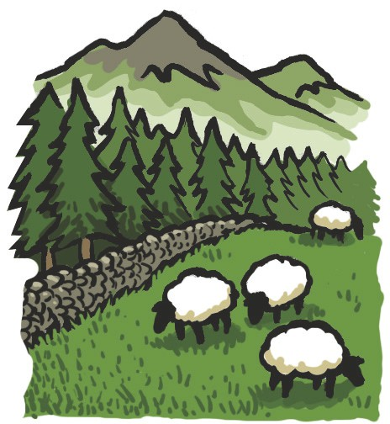
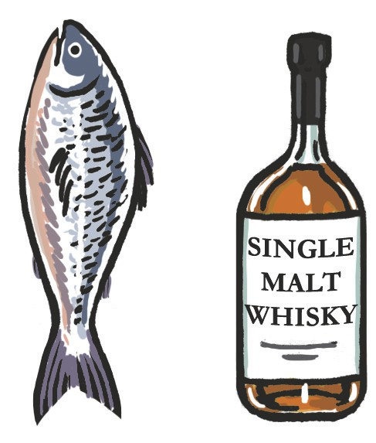
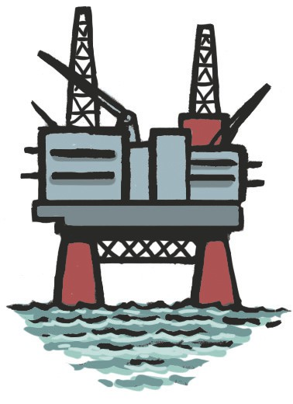
What the Scottish Government wants to do if Scotland becomes independent

Scotland’s countryside
Scottish farmers and people living in the countryside
should be doing as well as people like them across Europe.

An independent Scotland will work with the EU to get fairer support for Scotland’s farmers.
An independent Scotland will protect Scotland’s fishing
rights.

Food and drink
Scotland makes a lot of money from selling food and drink to other countries.

We could advertise Scottish food and drink all over the
world and make even more money if we were independent.

Energy
Scotland is an energy-rich nation. We have the largest
amount of oil in the EU and lots of renewable energy like wind and wave power.

If Scotland becomes independent we can make sure that money made from oil and gas is used to support Scottish public services.
We want to see energy bills being cheaper if Scotland is independent.

9

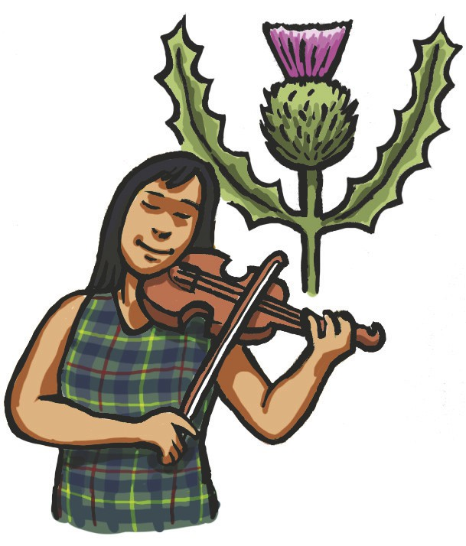
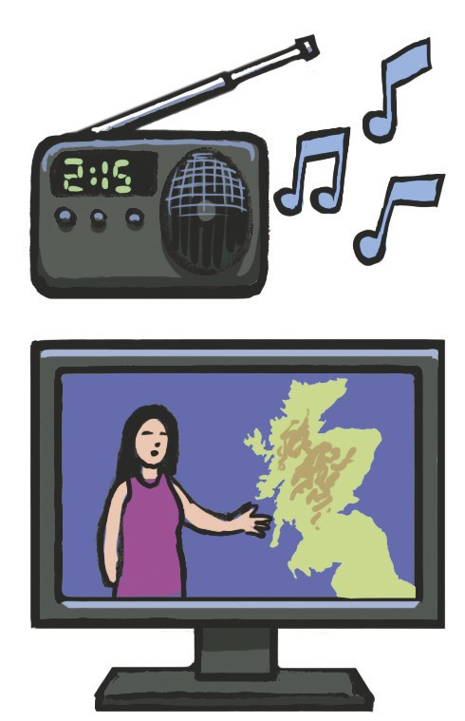
What the Scottish Government wants to do if Scotland becomes independent

Culture
We think Scotland’s culture and history are very important. We don’t just think that because of the money they bring to Scotland. We also think they are very important for our wellbeing and quality of life.

An independent Scotland will be able to put more money into the arts. This will build on the good reputation our culture has around the world.

TV and radio
If Scotland becomes independent we will set up the
Scottish Broadcasting Service (SBS). This will take over
from the BBC in Scotland and be paid for by a licence fee.
We will still have all the commercial channels we have now.
We want the SBS to form a partnership with the BBC so
that we would still get BBC programmes in Scotland.

10

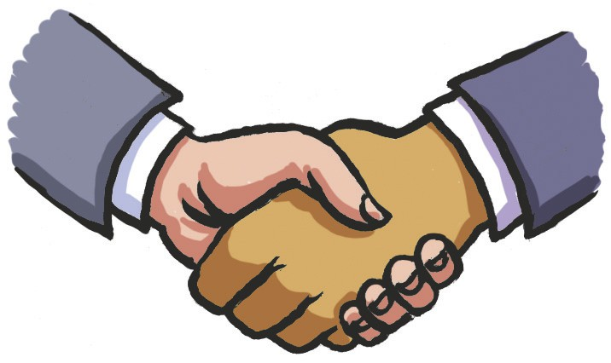
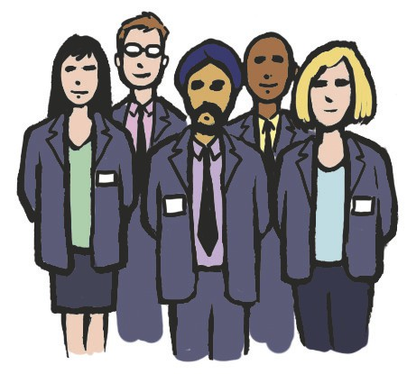
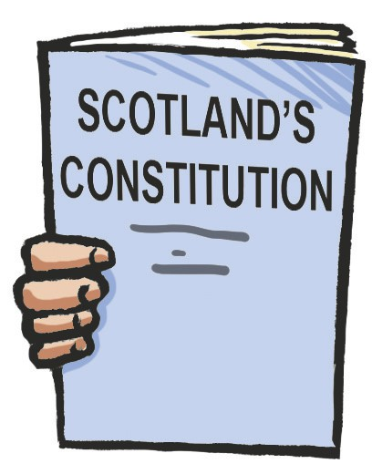
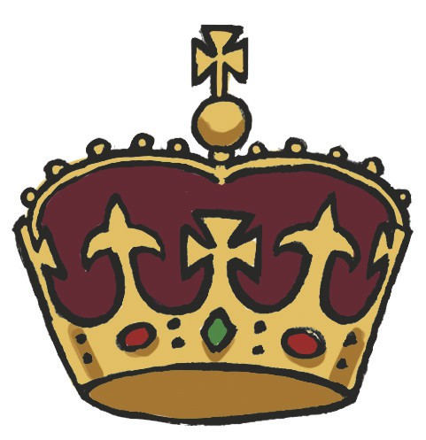
The change-over to independence

If Scotland votes for independence
we will start talks with the UK
Government straight away. Both
Governments will agree how Scotland will make the change to an
independent country.

The most important thing will be
making sure that public services are still delivered to citizens.

We will also talk with Europe about staying a member of the European Union.

Government and Civil Service
The Scottish Government will be in charge of more things if Scotland becomes independent. This will mean more
Government jobs for people across Scotland.

A modern constitution
A written constitution is a set of rules that say how a
country should be run. The UK does not have a written constitution.

Independence would let us make a written constitution
setting out how the country should be run and the rights of its citizens.
All the people of Scotland will have a chance to make our constitution.

The Monarchy
If Scotland becomes independent the Queen will still be head of state.

Published by the Scottish Government, May 2014 ISBN: 978-1-78412-484-7

© Crown copyright 2014
11
APS Group Scotland DPPAS28453 (05/14)

