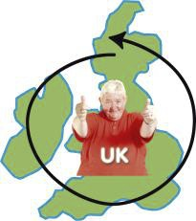
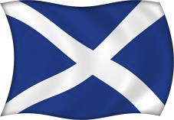
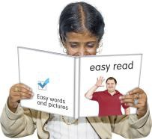
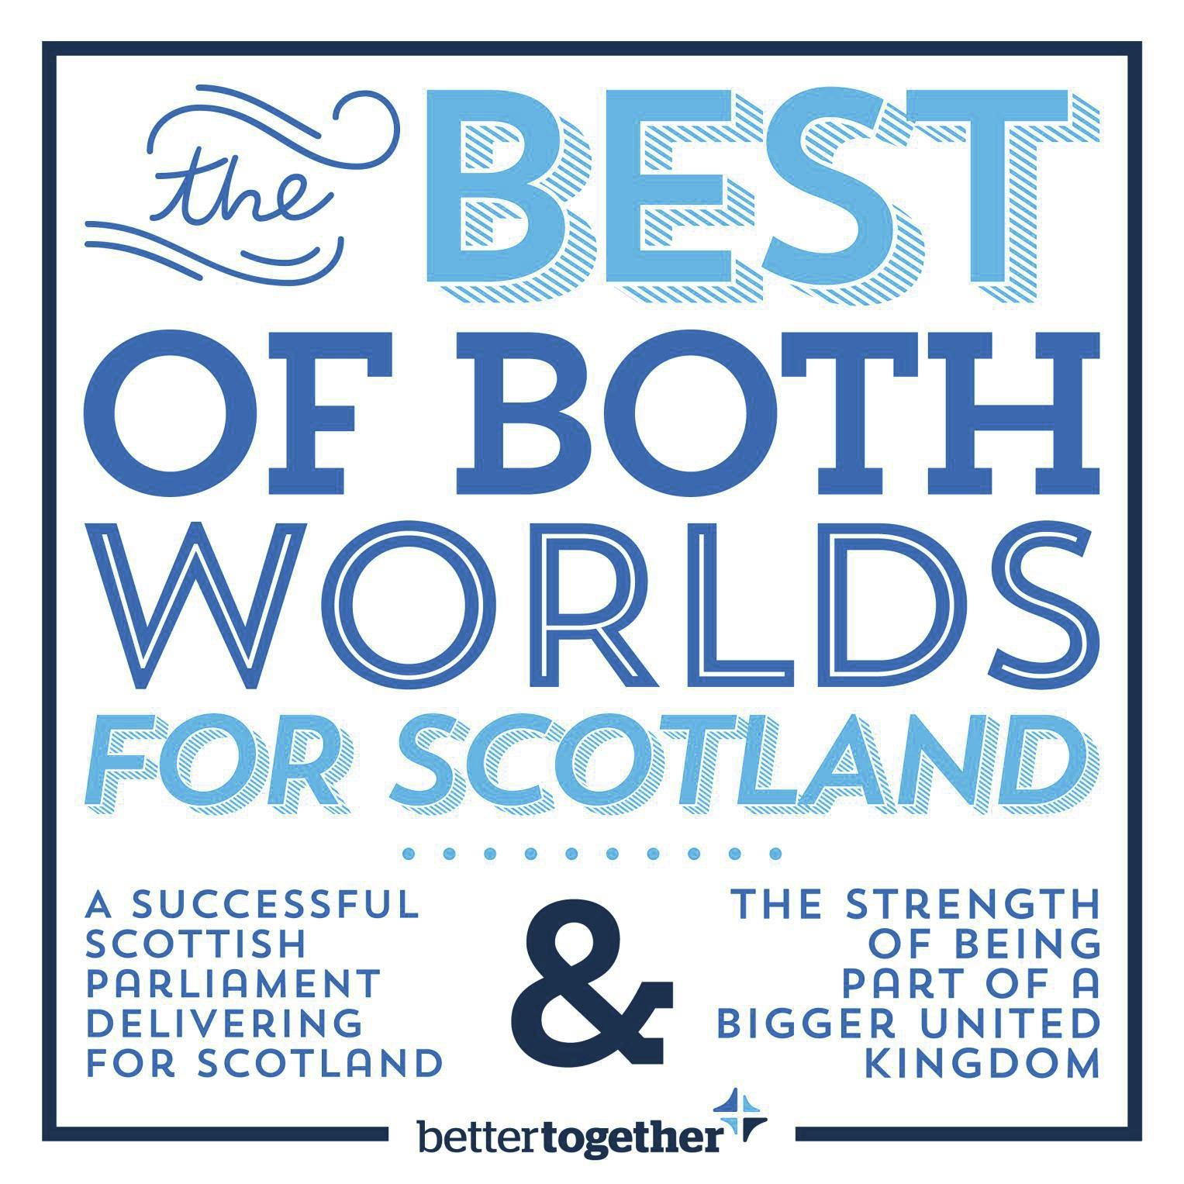

Why we are
Better Together
as part of the United
Kingdom
www.bettertogether.net

Proud to be Scottish inside the United Kingdom (with England, Wales and Northern Ireland)

Better Together is a campaign that believes Scotland is
better and stronger as part of the United Kingdom (UK).

Campaign means a group of people working together to achieve something they really believe in.

On 18 September 2014 people will vote about Scotland’s
future. This is called a referendum. There are 2 choices:

• Yes - I want Scotland to leave the UK.

• No - I do not want Scotland to leave the UK.

Better Together believes that a ‘No’ vote is the best choice
for Scotland. We are putting aside political differences to
NO do the right thing for Scotland. We all strongly believe that
Scotland will be safer and better if it stays part of a bigger
UK.

We are all proud to be Scottish and we know that there is nowhere better than Scotland. But most of us also feel at least a bit British.

We don’t have to choose between being Scottish and
British. In fact 800,000 of us live and work in other parts of
+ the UK. Many of us have family from across the whole of
the UK.

For 300 years Scotland has been a proud country inside the UK. This is especially true now when we have our own Scottish Parliament.

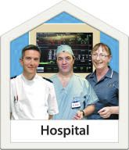
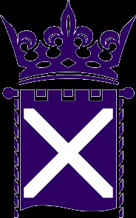
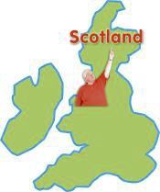
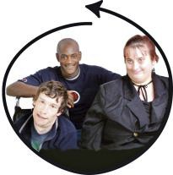
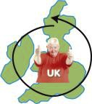
Devolution gives us the best of both worlds

Devolution means being part of the UK but having our
own parliament which makes important decisions for
Scotland.

Devolution gives us the best of both worlds: we have a strong Scottish Parliament which makes decisions in Scotland about Scotland. But we still get the benefits of sharing things with the rest of the UK.

We know it sometimes makes sense to share things with the rest of the UK. We understand that some things are easier when your friends and family are next to you. We are stronger when we work together.

➢ In the Scottish Parliament we decide what is best for
our universities. AND our universities get UK money
for Scottish scientists, doctors and inventors.

➢ We make decisions about the National Health Service
(NHS) in Scotland. AND we get free, easy access to
the specialist treatment our families need anywhere in
the UK NHS.

➢ We benefit from the success of the Scottish

+
Parliament. AND we benefit from sharing many good things with the rest of the UK.

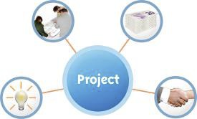
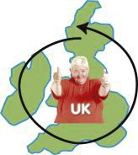
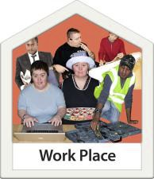
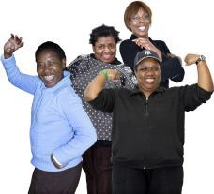
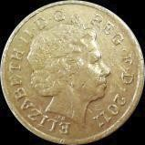
Working together to bring out the best in Scotland
We can bring out the best of Scotland by working
together across the UK. We have achieved so much
together. Working together in the future we can achieve so much more.
UK money makes green energy jobs and scientific
research possible in Scotland. This is also true for the
shipyards that give jobs to thousands of people. In return, the rest of the UK benefits from:
✓ Scottish clean energy.
✓ Medical research and inventions from Scottish
universities.
✓ Royal Navy ships built by clever Scottish engineers.
Everyone will be poorer if the 4 nations of the UK do not stick together.

Can we afford it?

Being part of the bigger UK is good for jobs in Scotland:
➢ Scottish companies sell 4 times as many products to
the rest of the UK as to the rest of the world.
➢ 200,000 Scottish jobs are with companies which sell
pensions and mortgages, where nearly all the
customers are from the rest of the UK.

Staying in the UK makes good money sense:
➢ We get the benefit of North Sea oil through spending
£1,200 more on each person than the rest of the UK.
When the oil runs out, the cost of cleaning up the oil
fields will be shared by all the UK.

We are stronger when we work together.

Keeping the Pound
The UK pound is one of the oldest, strongest and best kinds of money in the world.

As part of the UK, we can decide that we do not want to use European money (called the Euro). Using the UK pound means that we have not suffered as badly from the recent money problems Europe has had.

When Scottish banks had problems, a Scottish chancellor in the UK government put in a lot of money to stop them
going bust. The UK government was able to protect our
savings, mortgages and bank accounts. Taxpayers across the UK paid for this.

The only way to make sure we keep the pound is for Scotland to stay in the UK.

A powerful voice in the world
As part of the UK, we enjoy very special membership of the European Union (EU). The EU is a group of 28
countries who work together.
Because of its power in Europe the UK was able to make some special deals which have been good for Scotland. A separate Scotland would have to get special permission to use its own money instead of the Euro. No new EU
country has been able to get this permission.
The EU has a big effect on our lives. This means it is
important for Scotland to have a strong voice when
important decisions are made. As part of the UK we have this strong voice. It does not make sense to put this in danger by breaking up the UK.

If Scotland left the UK, it would have to ask again to become a member of the EU.

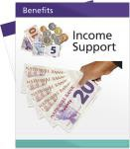
Our pensions are safer as part of the UK
We are living longer and working longer than ever before. People want to know that their pensions are safe.

Pension

The UK State Pension means that everyone in the UK can

get the same basic State Pension. It is a great example of
how we share good things across the UK. We all pay in
when we are working, and we all benefit when we retire.
This means we can support all our pensioners in the same way whether times are good or bad.
Scotland’s people are getting older at a faster rate than the
rest of the UK. This is good but it means that if we leave
the UK we could have a difficult choice to make between:
➢ Cutting the state pension.
➢ Increasing the age when people stop working. ➢ Increasing taxes.
➢ Cutting costs somewhere else.

It’s not worth the risk
If we vote to leave the UK we will have just over 500 days
before we have to set up a separate country. Here are
some of the big questions for which we have no answers:
➢ What money would we use?
➢ Would a foreign country decide our mortgage rates? ➢ How would benefits and pensions be paid?
➢ How much money would Scotland owe and how
would we pay this money?
➢ What would happen to our army, navy and air force?
Without the answers to these questions, a vote to leave the UK would be a huge leap into the dark. This is such a big decision that we need to be sure about it.

We should say no to the danger and uncertainty of leaving

NO
the UK. The best decision for Scotland is to vote for a better future working together.

10 Good Reasons why we are Better Together
1. Scotland sells more products to England, Wales and
Northern Ireland than to all other countries in the world.

2. 1 million Scottish pensions are safe in the UK system.
3. 1 in 5 workers in Scotland work for English, Welsh and
Northern Irish companies.

4. 45,000 workers in Scotland have jobs with the UK
Government.

5. As part of the UK, Scots can travel with the fewest
restrictions in the world.

6. 800,000 Scots live and work in England and Wales,
but do not need a passport or special papers to do this.

7. The UK has one of the biggest overseas aid budgets.

8. As part of the UK Scotland sits on the top table at the
United Nations with America, Russia, China and France.

9. The UK has been voted number one in the world for
spreading our international influence. As part of the UK
we can use this influence to do good in the world.

10. Scots are represented by more than 270 embassies
as part of the UK.
Volunteer on the Better Together campaign to make sure
we win this vote so that Scotland has a stronger future!

For more information:
➢ Go to: www.bettertogether.net
➢ Phone: 0141 225 6288
➢ Email: info@bettertogether.net

EasyRead by VoiceAbility
Pictures by PhotoSymbols4

