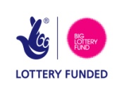
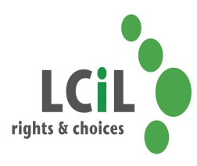
Independent Living and Work Choices Service

Are you a disabled person or a person with long term conditions living in the Lothian area and interested in:
- Living a more independent life?
- Accessing Employment/Further Education or Training?

- Developing your own action plan and achieving your goals with one to one support?
- Then this is for you…….!!

Lothian Centre for Inclusive Living is running a five year BIG lottery project which aims to support disabled people and people with long term conditions to maximise their potential and participation in community life.
Don’t delay, book today!
How does it work?

- You contact us


- One of our project staff will arrange to meet with you to welcome you


- You attend our FREE four day course covering Confidence, Disability Equality, Self Directed Support and a Working Life (Lunch is provided)

- Our project staff will offer you one to one follow up support to help you to achieve your goals
The next course……
- 15^{th,} 20th, 22nd & 27th May 2014!
- Norton Park, 57 Albion Road, Edinburgh

To register your interest or for an informal chat to find out more about the course, contact LCiL on 0131 475 2350
email
Elspeth.ferguson@lothiancil.org.uk or kelly.jack@lothiancil.org.uk
Website: www.lothiancil.org.uk



