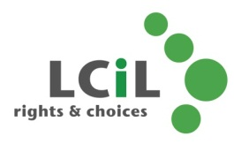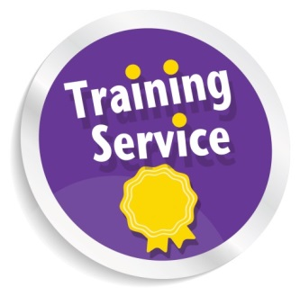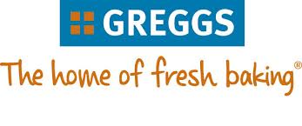MC900432423[1]MC900250740[1]MC900286855[1]

**Email**:amanda.beech@lothiancil.org.uk

**Phone**: 0131 475 2510

57 Albion Road

Edinburgh

EH7 5QY

Introductory Health & Food

Safety Course

LCiL Training Service

In Partnership with Greggs...

The popular 3 hour training course for disabled people who want to learn more about is back, with even more dates to come:

• Bacteria and causes of food poisoning

• Personal hygiene and hand washing

• Storage of food and kitchen safety

• Choosing the healthy option and more!

**Dates**: 7th May and 4th June 2014

**Time**: 11.30am—3pm

**Venue:** Greggs Bakery, Greggs Bakery, 36, Dryden Rd, Bilston Glen Industrial Estate, Midlothian EH20

Transport costs provided on request

**Refreshments provided by Greggs**

Rights & Choices for

Disabled people, people with long term conditions and older people in

Edinburgh and Lothian