Lothian Independent Advocacy Awareness Week
9-15th December 2013.

Independent Advocacy
Independent Advocacy is a way to help people have more influence and as much control as possible over their own lives.
There are lots of organisations in Lothian that provide Independent Advocacy, in different ways and for different groups of people. This leaflet explains what Independent Advocacy is and lists organisations in Lothian who provide Independent Advocacy that you can get in touch with.

What is Independent Advocacy?
Independent Advocacy is "independent" because Independent Advocacy organisations only provide advocacy they do not do anything else. Independent advocates and advocacy groups do not work for hospitals, social work services or any voluntary organisations that provide social care or support services.

Individual Independent Advocacy is provided one to one by advocacy workers, who can be paid or unpaid. It aims to:
- support people to represent their own interests
- represent the views of individuals if the person is unable to do this themselves
- provide advocacy support on specific issues
- provide information not advice so people can understand situations and make informed choices and decisions

Collective advocacy happens when a group of people with similar issues or experiences get together to support each other. Together they can raise issues and try to change things.

Some people find raising a difficult issue is easier with the support of a group. A group can have a stronger, louder voice than one person in taking forward shared issues, making groups more difficult to ignore.

The four main principles of Independent Advocacy are:
- Independent Advocacy puts the peo ple who use it first.
- Independent Advocacy is accountable.
- Independent Advocacy is as free as it can be from conflicts of interest.
- Independent Advocacy is accessible.
You can read more about these on the Scottish Independent Advocacy Alliance website http://www.siaa.org.uk

Independent Advocacy Services in Midlothian

CAPS
(Consultation and Advocacy Promotion Service)
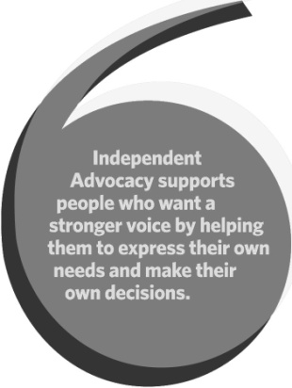
CAPS provides independent individual and collective advocacy in East Lothian and Midlothian for people who use, or have used, mental health services. They also support several experience led advocacy projects, relating to mental health across Lothian.
Old Stables Eskmills Parks Musselburgh
East Lothian EH21 7PQ Tel: 0131 273 S116
Individual Advocacy: 0131 273 S118
Email: contact@capsadvocacy.org
http://www.capsadvocacy.org

EARS Advocacy Service
EARS Advocacy Service provide independent individual and collective (group) advocacy to older people - in West Lothian, East Lothian and Midlothian; adults (16+) with physical disabilities and/or acquired brain injury in - West Lothian and Midlothian. EARS have also just started a new project working with people of any age who have survived a stroke - this is a Lothian wide service.
Forecourt Business Centre Ashley Place
Edinburgh EH6 SPX
Tel: 084S 607 0129/0131 SS3 8866
Email: info@ears-advocacy.org.uk www.ears-advocacy.org.uk

Partners in Advocacy
Partners in Advocacy provide independent individual advocacy for adults with learning disabilities in Edinburgh, East Lothian and Midlothian. They also provide independent individual advocacy for older people and adults with physical disabilities in Edinburgh.
2nd Floor, Beaverhall House 27/5 Beaverhall Road Edinburgh EH7 4JE
Tel: 0131 478 7723
Email: Edinburgh@partnersinadvocacy.org.uk
www.partnersinadvocacy.org.uk

