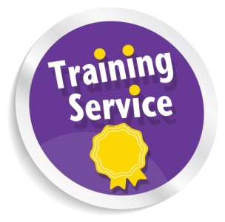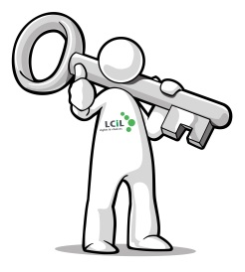facebooktwitter

As part of our Access to Work project, LCiL are holding further workshops for disabled people living in Edinburgh and the Lothians to find out more about Access to Work (AtW) and peer support.

Access to Work is a government funded programme providing support to disabled people and employers so that more disabled people can take up jobs and get necessary adjustments paid for so that employment opportunities are accessible.

The next event is taking place on:

**14th January 2014,**

Time: **6.00-8.30pm**

At: **The Training Suite in**

Norton Park Conference Centre, 57 Albion Road, Edinburgh,

EH7 5QY.

**At these workshops:**

You can find out what Access to Work is, and how to be supported at work or support disabled staff. There will also be opportunities to discuss how disabled people taking part in the project can support each other through peer support groups.

This particular workshop will be useful for younger people (aged 16-25 years old) although other disabled people and support organisations if they wish to attend.

**Travel costs can be met on request!**

Light refreshments will be available

To find out more and book a place contact

Amanda on 0131 475 2350 or

Email: [Amanda.beech@lothiancil.org.uk](mailto:Amanda.beech@lothiancil.org.uk)

Address: 57 Albion Road Edinburgh EH7 5QY

Rights and choices for disabled people, people with long term conditions and older people in Edinburgh and the Lothians

## To get the latest updates on

## Access to Work project with LCiL

## 

## **Contact Amanda**

## On 0131 475 2350/2510

## 

## Email:amanda.beech@lothiancil.org.uk

## 

## Visit the project on our website: www.lothiancil.org.uk

## 

## Follow on

## Twitter:

## @LothianCIL

## 

## Check out on

## Facebook:

## Lothian-Centre-for-Inclusive-Living

## 

**Access to Work Information**

**Workshops are coming your way in 2014!**