|  |
| --- |
| More Dates coming up for LCiL’sAccess to Work Project’s series ofInformationWorkshops forDisabled People and Parents/Carers**Have now been confirmed!** Venue: Norton Park in the Training Suite**contact** **Amanda**On 0131 475 2350/2510To Book a Place!Access to WorkOfficers will becontributing to theprogramme at each event! |

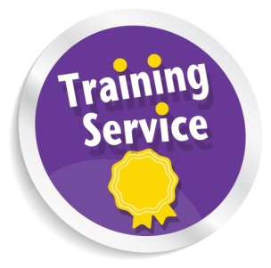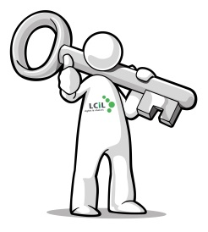

**Access to Work Information**

**Workshops are coming your way!**

**Email**: Amanda.beech@lothiancil.org.uk

**Phone**: 0131 475 2350/2510

57 Albion Road Edinburgh

EH7 5QY

Rights & Choices for

Disabled people, people with long term conditions and older people in

Edinburgh and Lothian

Light refreshments such as: teas; coffees; juices and cakes will be available, a great chance to find out more, in a comfortable small group setting.

**All you need to do is to sign up now, and I will do the rest!**

As part of our Access to Work project, LCiL are holding further workshops in December for parents/carers of Disabled People who want to find out more about AtW and what it actually means for disabled people in real terms.

The dates are:

**4th December** Time **10-12.30pm** (these two workshops would be for parents/carers of 14-25yrs) then **again** at **6-8.30pm** for those who cannot make in the day because of work commitments

**10th December**

Time: **6-8.30pm** (this one would be for parents/carers of adults 26 years and above)

Venue would be the **training suite** at Norton Park

Then **14th January 2014**

Workshop for young people with additional support needs (16 - 25)

Time: **6-8.30pm**

**At these workshops:**

**You** can find out what is Access to Work, and get up to date with all the changes that are happening within the service.

It will be useful for those who may be thinking of going into new employment or are already in employment and require additional support to remain in their work!

**Travel costs can be met on request!**

**Employers/Support Organisations** can find out how they can assist their employees to remain in their work when they find out they have been diagnosed with a long term condition

All ages and all impairments are covered by A2W, so why not come and spend a couple of hours at a workshop or information session and see how we can help give you the information you need and help you to understand how A2W could help you!

Dates: **4th September** Time: **1-3pm**

**10th October** Time: **1-3pm**